# https://upload.wikimedia.org/wikipedia/en/f/f1/Capital_University%2C_Jharkhand_logo.png

# CAPITAL UNIVERSITY - KODERMA

ELECTRO-MECHANICAL ENERGY CONVERSION DEVICE – 2 ASSIGNMENT

Name : Arshad Nazir

Electrical and Electronics Engineering

Signature:

Date :

PART I

1. Why a 3-phase synchronous motor will always run at synchronous speed?

A sync motor works like two magnetically joined poles - one fixed (field) and other free to rotate (rotor). As the field changes polarity, the rotating pole seeks to follow the next pole. It works like two magnetics atraction instead as current repulsion (like async motors do) so the speeds are the same i.e. the poles are synchronized. So they can’t rotate at diferent speeds.

1. What are the two classification synchronous machines?

Based on the armature winding and field winding arrangement, synchronous machines are classified into two types: Rotating Armature type and Rotating Field type.

* + In rotating armature type, the armature winding is housed in the rotor. The emf generated or current is supplied to the load via slip ring and carbon brush assembly. This type of synchronous machine is only built for small rating machine.
  + In rotating field type synchronous machine, filed winding is wound on the rotor. DC supply is extended to the field winding by assembly of slip ring and carbon brush. Electrical power is supplied to the load using stationary terminals mounted on the stator. This type is more famous and widely used in large sized synchronous machine.

1. What are the essential features of synchronous machine?

Synchronous Motor and Synchronous Generator are together refereed as Synchronous machine. A synchronous machine consists of two main parts: Stationary part known as *Stator* and Rotating part known as *Rotor*.

Stator

Stator is the outer stationary part of the machine which consists of two main parts: Yoke – This is outer cylindrical stationary frame and made up of either cast steel or cast iron.

Stator Core – It is the magnetic core which is slotted to accommodate armature winding. It comprises of set of slotted steel laminations pressed into the cylindrical

space inside the outer frame. Stator core is made of laminated sheet of 0.5 mm thick CRGO to reduce [eddy current](https://electricalbaba.com/what-is-eddy-current-concept-of-electromagnetic-damping/) losses.

Rotor

Rotor is that part of synchronous machine which can rotate. It carries the field winding. From construction point of view, there are two types of rotor: Salient Pole Rotor and Cylindrical Pole Rotor. Cylindrical pole rotor is also known as round rotor or non-salient pole rotor.

1. Mention the methods of starting of 3-phase synchronous motor. The different methods used to start a synchronous motor are :

Using Pony Motors :

By using the small pony motors like a small induction motor, we can start the synchronous motor. This small induction motor is coupled to the rotor of the synchronous motor. The function of this induction motor is to bring the rotor of the synchronous motor to the synchronous speed.

Once the rotor attains the synchronous speed the pony motor is dis-coupled from the rotor. The synchronous motor continues to rotate at synchronous speed, by supplying d.c. excitation to the rotor through the slip-rings. One should remember that the motor used as the pony motor must have less number of poles than the synchronous motor used.

Using Small D.C. Machine :

In the above method, we have a seen small induction motor to start the motor. Here we use d.c. motor instead of induction motor to bring the motor to synchronous motor.

Once the d.c. motor brings the rotor of the synchronous motor to synchronous speed. The motor starts acting as the [d.c. generator](https://www.electricaldeck.com/2020/01/working-principle-of-dc-generator.html) and starts giving excitation to the field winding of the synchronous motor.

Using Damper Winding :

When a 3-phase supply is given to the synchronous motor it fails to start. In order to make it start copper bars circuited at both ends ( similar to the squirrel cage rotor of an induction motor ) are placed on the rotor, these bars or winding are known as 'Damper Winding'.

Now when the supply is given the field winding setups a rotating magnetic field. Due to the damper winding used, the rotor starts rotating as an induction motor i.e., less than the synchronous speed at starting. Once d.c. excitation is given to the field winding and the motor is then pulled into synchronism.

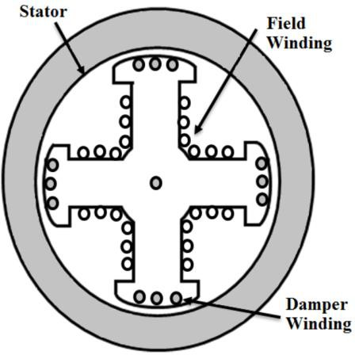

The damper winding is used to start the motor and hence can be used for starting purposes only. Because once the rotor rotates at synchronous speed the relative motion between the damper winding and rotating magnetic will be equal, and hence induced [emf](https://www.electricaldeck.com/2020/04/emf-equation-of-synchronous-generator-or-alternator.html) and current will be zero. The damper winding will be out of the circuit.

1. What are the principal advantages of rotating field system type of construction of synchronous machines?

The advantages of rotating field system are given below. a. For rotating field alternators only two slip rings and brush gear assembly are required irrespective of number of phases.

1. The DC excitation voltage is low and it is very easy to insulate. This intern reduces the size of the machine.
2. Out put current can be taken directly from the fixed terminals on the stator. It is easy to insulate high voltage stationary stator (armature).
3. The armature winding can be easily braced to prevent any deformation produced by the mechanical stress set as a result of short circuit current and the high centrifugal brought into play.
4. Write down the equation for frequency of emf induced in an alternator The frequency of the induced EMF is given by

𝑓 = 𝑛×𝑃

120

P is the number of poles in the alternator and n is the speed of rotation in radials per minute

1. What are the advantages of salient pole type of construction used for synchronous machines

Advantages of salient-pole type construction are :

* They allow better ventilation
* The pole faces are so shaped that the radial air gap length increases from the pole center to the pole tips so that the flux distribution in the air-gap is sinusoidal in shape which will help the machine to generate sinusoidal emf
* Due to the variable reluctance the machine develops additional reluctance power which is independent of excitation

1. Why do cylindrical rotor alternators operate with steam turbines?

Steam turbines are found to operate at fairly good efficiency only at high speeds. The hig h speed operation of rotors tends to increase mechanical losses and so the rotors should have a smooth external surface. Hence, smooth cylindrical type rotors with less diameter and large axial length are used for Synchronous generators driven by steam turbines with either 2 or 4 poles.

1. Which type of synchronous generators are used in Hydroelectric plants and why?

The majority of hydroelectric installations utilize salient pole synchronous generators. Salient pole machines are used because the hydraulic turbine operates at low speeds, requiring a relatively large number of field poles to produce the rated frequency. A rotor with salient poles is mechanically better suited for low-speed operation, compared to round rotor machines, which are applied in horizontal axis high-speed turbo-generators.

1. What is the relation between electrical degree and mechanical degree?

Mechanical degrees: the degree of physical or mechanical rotation a single conductor in an alternator.

Electrical degrees: the degree or the cycle of emf induced in a single conductor in an alternator

Consider a Two pole Alternator, when a conductor rotates in the feild, the emf induced in the conductor will be maximum when the conductor is at the center of the pole and the emf induced will be minimum when the conductor is in the middle of the gap between the two poles. so when we consider the graph of the induced emf versus the position or degree of rotation. For one complete rotation of the condutor in the feild - One complete cycle of emf is generated in the conductor (Positive half cycle at south pole and negative halfcycle at north pole).

The same way when we consider a 4 pole alternator a single conductor when completing one mechanical rotation will cross the four poles there by giving the induced emf graph with two positive half cycles and two negative halfcycles which gives us two complete cycles of induced emf.

So for One Mechanical rotation (360 degrees) the induced emf completes two cycles (360 * 2 = 720 degrees in terms of the sine wave)

So the relation between Electrical and Mechanical degrees can be written as

Elect. Degrees = (N0. of Poles / 2) * Mech. Degrees

1. What is the meaning of electrical degree?

Electrical degree is used to account the angle between two points in rotating electrical machines. Since all electrical machines operate with the help of magnetic fields, the electrical degree is accounted with reference to the polarity of magnetic fields. 180 electrical degrees is accounted as the angle between adjacent North and South poles.

1. Why short-pitch winding is preferred over full pitch winding?

Short-pitch winding is preferred over full pitch winding due to the following reasons:

* Waveform of the emf can be approximately made to a sine wave and distorting harmonics can be reduced or totally eliminated.
* Conductor material , copper , is saved in the back and front end connections due to less coil-span.
* Fractional slot winding with fractional number of slots/phase can be used which in turn reduces the tooth ripples.
* Mechanical strength of the coil is increased.

1. Write down the formula for distribution factor.

Distribution factor is defined as the ratio of [phasor](https://electricalbaba.com/differences-between-a-phasor-and-a-vector/) sum of coil emfs to the arithmetic sum of coil emfs. It is also known as Belt or Breadth factor and denoted by kd.

kd = Phasor sum of coils emf / Arithmetic sum of coils emf Calculation of Distribution Factor

To get a general expression or formula of distribution factor, let us assume a 2 pole,

3 phase electrical machine having a total of 18 slots in its stator. These slots are distributed along the periphery of stator in 2 pole pitches. Therefore the angle between any two consecutive slots will be equal to 20 degree (2×180 / 18 = 20). This angle between two consecutive slots is called *Angular Slot Pitch*. It is in [electrical](https://electricalbaba.com/concept-of-electrical-and-mechanical-angles-synchronous-speed/) degree not in mechanical degree.



Thus angular slot pitch for our example is 20 degree. The number of slots per pole per phase will be 3 [(18/2)/3 = 3]. This means that a particular phase will consists of three coils distributed in three slots under a single pole. This is shown in figure below.

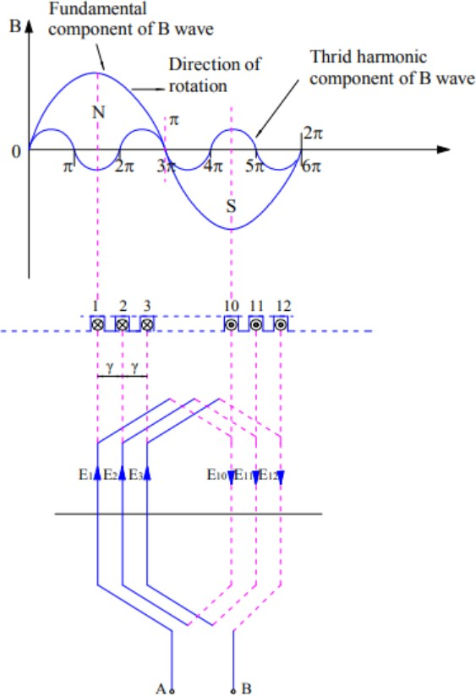

In the above figure it can be seen that, coils are distributed in slot number 1,2,3 and 10,11,12. It can also be observed that, coil sides are connected in series in such a way that emf induced in coil side at 1 and 10 are additive. This means, if E1 and E10 are the [emf induced](https://electricalbaba.com/how-does-motional-emf-produced/) in respective coil sides then the total emf induced will be E1+E10. Similarly, if the emf induced in coil sides 2 and 11 are E2 & E11, then the total emf in coil 2-11 is given as arithmetic sum of E2 and E11.

Thus the total emf at the coil terminal A & B is the phasor sum of (E1+E10), (E2+E11) and (E3+E12). Let us assume (E1+E10) as reference phasor and draw the phasor diagram of the above three emf to get the total emf available at terminal AB.

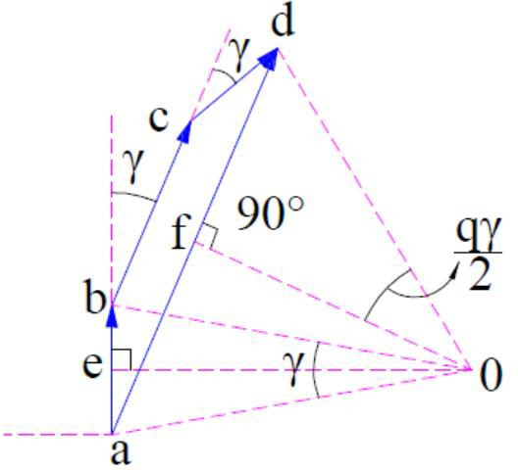

In the above phasor, ab represents (E1+E10). Since the slots are displaced from each other by angular slot pitch of γ (in our example, it is 20 degree), this means the emf induced in coil 2-11 will be displace by an angle of γ from reference phasor ab. This is shown by ‘bc’ in above phasor. Similarly, ‘cd’ represents the emf induced in coil 3-12 and is displaced by reference phasor by and angle of 2γ.

Thus the total emf across terminals AB of coil will be the phasor sum of ab, bd and cd which is equal to ‘ad’. Let us now calculate this phasor sum.

Since ab, bc and cd are lying in stator slot, therefore their perpendicular bisector must meet at the centre of the circle. Let us now draw perpendicular bisector oe and of on ab and ad respectively as shown in above figure. In general, the angle aob should be equal to angular slot pitch γ, angle aod equal to qγ and angle aof equal to (qγ/2) where q is number of slots per pole per phase.

In right angled triangle aoe,

Sin (γ/2) = ae / oa ae = oaSin(γ/2)

Thus, ab = 2oaSin(γ/2) as oe is perpendicular bisector of ab.

Therefore, if the coil were concentrated then the emf across coil terminal AB would have been arithmetic sum of emf. This is given as

Emf per coil = Number of slots per pole per phase x 2oeSin(γ/2)

= 2q(oa)Sin(γ/2) Now, in right angled triangle aof,

Sin(qγ/2) = af / oa af = (oa)Sin(qγ/2)

Hence the resultant emf ad equal to the phasor sum of ab, bc and cd is given as

ad = 2(oa)Sin(qγ/2)

Therefore as per the definition of distribution factor,

kd = Phasor Sum of Coil emf / Arithmetic sum of coil emf

= ad / q ab

= [2(oa)Sin(qγ/2)] / [2q(oa)Sin(γ/2)]

= Sin(qγ/2) / qSin(γ/2)

Thus the formula for distribution factor is given as below. Distribution factor kd = Sin(qγ/2) / qSin(γ/2)

where q is number of slots per pole per phase and γ is angular slot pitch.

1. Define winding factor.

The winding factor is the method of improving the rms generated voltage in a three- phase AC machine so that the torque and the output voltage do not consist of any harmonics which reduces the efficiency of the machine. Winding Factor is defined as the product of the Distribution factor (Kd) and the coil span factor (Kc). The distribution factor measured the resultant voltage of the distributed winding regards concentrate winding and the coil span is the measure of the number of armature slots between the two sides of a coil. It is denoted by Kw.

1. Why are alternators rated in kVA and not in kW?

The alternator conductors are calculated for a definite current and the insulation at magnetic system are designed for a definite voltage independent of p.f. (Cos θ) of the load. *For this reason* [*apparent power*](https://www.electricaltechnology.org/2013/07/active-reactive-apparent-and-complex.html) *measured in kVA is regarded as the rated power of the alternator.*

The main factors manufacturers consider while designing electrical devices and appliances which provide electric power like [transformer](https://www.electricaltechnology.org/2012/02/working-principle-of-transformer.html), UPS, alternators and generators,etc are load and power factor. As they don’t know exactly what is power factor and which kind of load will be connected to the device and appliances.

So they simply design and rate the electrical device according to its maximum current output that the conductors can safely carry while they consider unity power factor (In case of pure resistive load).

If we connect inductive or capasitive load (When power factor is not at least unity), The output would differ than as there are [losses occurs due to low power factor](https://www.electricaltechnology.org/2013/08/disadvantages-of-low-power-factor.html).

For this reason, KVA is an apparent power which does not take in to account the PF (Power factor) instead of KW (Real Power).

Where:

KW= KVA X Cos θ

And kVA = KW / Cos θ.

1. What are the causes of changes in voltage of alternators when loaded?

Whenever the load on the alternator is varied, the terminal voltage will also vary. This variation in terminal voltage is mainly due to three reasons: Voltage drop due to armature resistance IRa, Voltage drop due to armature leakage reactance IXL and Voltage drop due to armature reaction.

Voltage drop due to armature resistance

The armature winding resistance per phase will cause a IRa voltage drop per phase. The voltage drop due to armature resistance is in phase with the armature current I. Practically, this voltage drop is negligible.

Voltage drop due to armature leakage reactance

When current flows through armature conductors, the flux will start to flow through the armature core. Some flux will take different paths and do not cross the air gap and are called leakage flux.

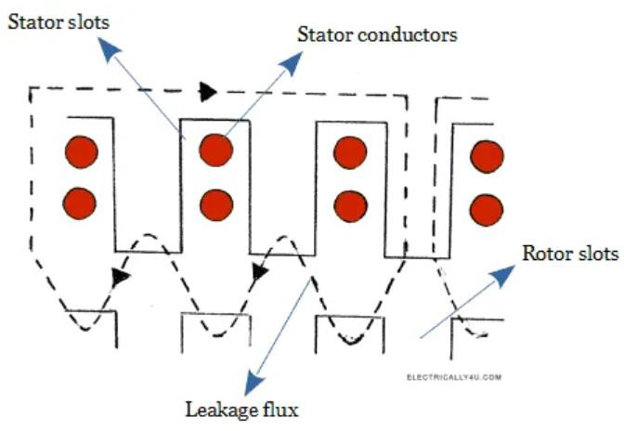

Here, the leakage flux depends on the current flowing through the conductor and its phase relationship with the terminal voltage. This leakage flux will set up an emf because of self-inductance. This emf is known as reactance emf, which leads the armature current I by 900.

Thus, the armature winding is said to possess a leakage reactance XL. The voltage drop due to this reactance is IXL. The generated emf has to overcome the voltage drop due to leakage reactance to give its output.

*E = V + I ( Ra + jXL )*

This is illustrated in the below phasor diagram.

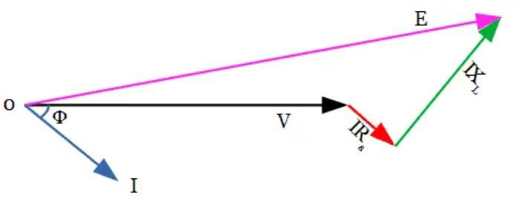

The above phasor diagram is constructed as below,

* The voltage phasor is taken as the reference phasor.
* The armature current lags behind the voltage by an angle Φ. Hence the current phasor is drawn at an angle Φ from the voltage phasor.
* The phasor for armature resistance drop is drawn parallel to the current phasor from the extremity of Voltage phasor V.
* Leakage reactance drop is drawn perpendicular to the current phasor from the extremity of IRa phasor.
* Join 0 and the extremity of IXL phasor to get Eb.

Voltage drop due to armature reaction

[Armature reaction](http://www.electrically4u.com/armature-reaction-in-alternator/) is the effect of armature flux on the main field flux. The effect of Armature reaction can be seen in the DC generator as well.

But compared to the [DC generator](http://www.electrically4u.com/construction-of-dc-generator/), the power factor of the load in an alternator has a considerable effect on armature reaction. While we talk about the power factor on loading conditions, we consider three cases.

* Unity power factor load.
* Zero power factor lagging load
* Zero power factor leading load.

The [armature reaction in alternator](http://www.electrically4u.com/armature-reaction-in-alternator/) produces different effects such as cross magnetizing effect, demagnetizing effect, magnetizing effect. These effects cause distortion in main field flux, thereby affecting the generated emf.

The voltage drop due to armature reaction may be assumed as there is a presence of fictitious reactance Xa called armature reactance reaction. The voltage drop due to armature reactance reaction is represented as IXa.

The leakage reactance XL and armature reaction reactance Xa together called as synchronous reactance XS.

*XS = XL + Xa*

Thus the voltage drop in an alternator under loaded conditions is the total sum of voltage drop due to armature resistance, armature leakage reactance, and armature reaction reactance.

*V = I Ra + j I XL + j I Xa = I ( Ra + j XL + j Xa ) = I ( Ra + j ( XL + Xa ) )*

V *= I ( Ra + j XS ) = I ZS*

Where *ZS* is known as synchronous impedance of an alternator.

From the discussions above, it is clear that the variation in load causes the

PROFESSIONAL ENGINEERING CREDITS ASSESSMENT & EVALUATION PART IA UNIVERSITY EXAM QUESTION PATTERN – 6 MARK (EACH QUESTION CARRIES 6 MARKS) ANSWER ANY 10 QUESTION

1. Describe with neat sketches the constructional details of a salient pole type alternator.
2. Draw a neat sketch showing the various parts of a synchronous machine. State the type of synchronous generator used in nuclear power stations.

Construction of a Synchronous Machine, i.e. alternator or motor consists of two main parts, namely the stator and the rotor. The stator is the stationary part of the machine. It carries the armature winding in which the voltage is generated. The output of the machine is taken from the stator. The rotor is the rotating part of the machine. The rotor produces the main field flux.

The important parts of the Synchronous Machine are given below:

* + Stator
  + Rotor
  + Miscellaneous Stator Construction

The stationary part of the machine is called Stator. It includes various parts like stator frame, stator core, stator windings, and cooling arrangement. They are explained below in detail.

Stator Frame

It is the outer body of the machine made of cast iron, and it protects the inner parts of the machine.

Stator Core

The stator core is made of silicon steel material. It is made from a number of stamps that are insulated from each other. Its function is to provide an easy path for the magnetic lines of force and accommodate the stator winding.

Stator Winding

Slots are cut on the inner periphery of the stator core in which 3 phase or 1 phase winding is placed. Enameled copper is used as a winding material. The winding is star-connected. The winding of each phase is distributed over several slots. When the current flows in a distributed winding it produces an essentially sinusoidal space distribution of EMF.

Rotor Construction

The rotating part of the machine is called Rotor. There are two types of rotor construction, namely the salient pole type and the cylindrical rotor type.

Salient Pole Rotor

The term salient means projecting. Thus, a salient pole rotor consists of poles projecting out from the surface of the rotor core. The end view of a typical 6 pole salient pole rotor is shown below in the figure:

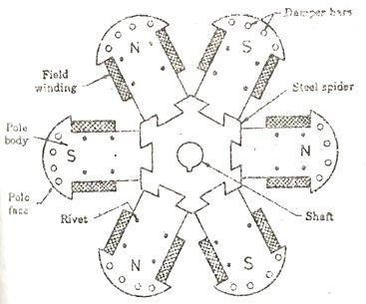

Since the rotor is subjected to changing magnetic fields, it is made of steel laminations to reduce eddy current losses. Poles of identical dimensions are assembled by stacking laminations to the required length. A salient pole synchronous

machine has a non-uniform air gap. The air gap is minimized under the pole centers and it is maximum in between the poles.

They are constructed for medium and low speeds as they have a large number of poles. A salient pole generator has a large diameter. The salient pole rotor has the following important parts.

Spider: It is made of cast iron to provide an easy path for magnetic flux. It is keyed to the shaft and at the outer surface, pole core and pole shoe are keyed to it.

Pole Core and Pole Shoe: It is made of laminated steel sheet material. The Pole core provides the least reluctance path for the magnetic field and the pole shoe distributes the field over the whole periphery uniformly to produce a sinusoidal wave.

Field Winding or Exciting Winding: It is wound on the former and then placed around the pole core. DC supply is given to it through slip rings. When direct current flows through the field winding, it produces the required magnetic field.

Damper Winding: At the outermost periphery, holes are provided in which copper bars are inserted and short-circuited at both sides by rings forming Damper winding.

Non- Salient Pole Rotor or Cylindrical Rotor

In this type of rotor, there are no projected poles, but the poles are formed by the current flowing through the rotor exciting winding. Cylindrical rotors are made from solid forgings of high-grade nickel chrome-molybdenum steel. It has a comparatively small diameter and long axial length.

They are useful in high-speed machines. The cylindrical rotor type alternator has two or four poles on the rotor. Such a construction provides greater mechanical strength and permits more accurate dynamic balancing. The smooth rotor of the machine makes fewer windage losses and the operation is less noisy because of the uniform air gap.

The figure below shows the end view of the 2 poles and 4 pole cylindrical rotors.

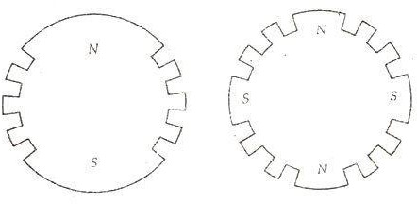

They are driven by steam or gas turbines. Cylindrical synchronous rotor synchronous generators are called turbo-alternators and turbo generators. The machines are built in a number of ratings from 10 MVA to over 1500 MVA. The biggest size used in India has a rating of 500 MVA installed in the super thermal power plant.

Non-salient pole-type rotors have the following parts. They are as follows:

Rotor Core: The rotor core is made of silicon steel stampings. It is placed on the shaft. At the outer periphery, slots are cut in which exciting coils are placed.

Rotor Winding or Exciting Winding: It is placed on the rotor slots, and the current is passed through the winding in such a way that the poles are formed according to the requirement.

Slip Rings: Slip rings provide DC supply to the rotor windings. Miscellaneous Parts

The miscellaneous parts are given below:

Brushes: Brushes are made of carbon, and they slip over the slip rings. A DC supply is given to the brushes. Current flows from the brushes to the slip rings and then to the exciting windings.

Bearings: Bearings are provided between the shaft and the outer stationary body to reduce the friction. They are made of high carbon steel.

Shaft: The shaft is made of mild steel. Mechanical power is taken or given to the machine through the shaft.

Four pole steam turbine generators are most often found in nuclear power stations as the relative wetness of the steam makes the high rotational speed of a two-pole design unsuitable.

Most [generators](https://electrical-engineering-portal.com/download-center/books-and-guides/electrical-engineering/introduction-to-motor-and-generator) with gas turbine drivers are *four pole machines* to obtain enhanced mechanical strength in the rotor- since a gearbox is often used to couple the power turbine to the generator, the choice of synchronous speed of the generator is not subject to the same constraints as with steam turbines.

Generators with diesel engine drivers are invariably of four or more pole design, to match the running speed of the driver without using a gearbox. Four-stroke diesel engines usually have a *higher running speed* than two-stroke engines, so generators having four or six poles are most common.

This requires a generator with a large number of poles (48 for a 125rpm, 50Hz generator) and consequently is of large diameter and short axial length. This is a contrast to turbine-driven machines that are of small diameter and long axial length.

1. Discuss briefly the load charactertics of alternator for different power factor.

To draw the phasor diagrams, let us know the terms used in the below diagrams.

*E0* is the no-load voltage. It is the maximum voltage induced in the armature without giving any load.

*E* is the load voltage. It is the induced voltage after overcoming the armature reaction. *E* is vectorially less than the no-load voltage.

*I* is the armature current per phase

*V* is the terminal voltage. It is vectorially less than *E* by *IZ* and also vectorially less than *E0* by *IZS*.

*Φ* is the cosine angle between terminal voltage and current. The impedances are given by

Z = 𝑅𝑎 + j𝑋𝐿 = √( 𝑅𝑎 2 + 𝑋𝐿 2)

𝑍𝑆 = 𝑅𝑎 + j𝑋𝑆 = √( 𝑅𝑎 2 + 𝑋𝑆2)

where *XL* is the leakage reactance, *Xa* is the armature reaction reactance and *XS* is the synchronous reactance and *ZS* is the synchronous impedance.

Unity power factor load

The phasor diagram of an alternator for unity power factor load is shown below.

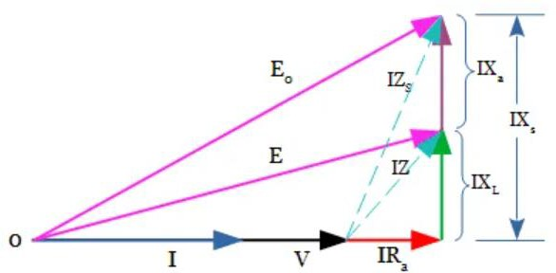

Phasor diagram is drawn following the below procedure.

1. Voltage phasor V is taken as the reference phasor.
2. For unity power factor load, V and I phasor are in phase. So the Current phasor I is drawn on the voltage phasor V.
3. The phasor of Armature resistance drop IRa is drawn parallel to the current phasor from the extremity of V phasor.
4. The armature leakage resistance drop IXL is drawn perpendicular to the current phasor, from the extremity of IRa phasor.
5. Join V phasor and IXL phasor to get IZ phasor(shown as a dotted line).
6. Join O and the extremity of IZ to get E
7. Draw the armature reaction reactance drop phasor IXS perpendicular to the current phasor from the extremity of IXL phasor.
8. Join V phasor and IXS phasor to get IZS phasor(shown as a dotted line).
9. Join O and the extremity of IZS to get E0

Lagging power factor load

The phasor diagram of an alternator for lagging power factor load is shown below.

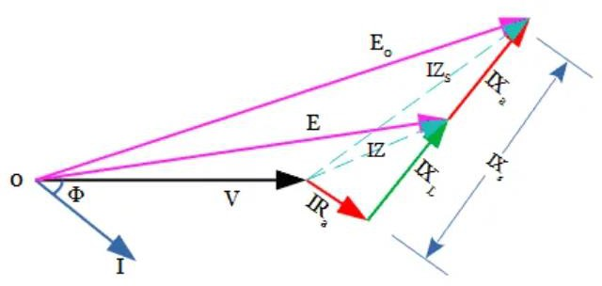

The above phasor diagram is drawn by following the same procedure as explained for unity power factor.

The only change is that here current lags behind the voltage by an angle *Φ*. So draw the current phasor at an angle *Φ* with respect to voltage phasor V.

Leading power factor load

The phasor diagram of an alternator for leading power factor load is shown below.

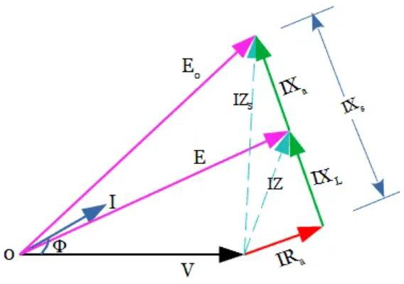

For the leading power factor load, the phasor diagram is also drawn similar to that of the unity power factor. But the only difference is that here current leads the voltage by an angle Φ. So the current phasor is drawn at an angle *Φ* with respect to voltage phasor V.

4. Explain any one method of predetermining the regulation of an alternator.

Zero power factor (ZPF) method is used to determine the voltage regulation of synchronous generator or alternator. This method is also called Potier method. In the operation of an [alternator](http://www.electricalengineeringinfo.com/2014/08/principle-and-working-of-synchronous-generator-alternator.html), the armature resistance drop IRa and armature leakage reactance drop IXL are actually emf quantities while the armature reaction is basically MMF quantity. In the synchronous Impedance, all the quantities are treated as EMF quantities as against this in [MMF method](https://www.electricalengineeringinfo.com/2016/12/mmf-ampere-turn-method-for-determining-voltage-regulation-alternator.html) all are treated as MMF quantities.

Key Point: This zpf method is based on the separation of armature leakage reactance and armature reaction effects. The armature leakage reactance XL is called Potier reactance in this method, hence ZPF method is also called Potier reactance method.

To determine armature leakage reactance and armature reaction MMF separately two tests are performed on the [alternator](http://www.electricalengineeringinfo.com/2014/08/principle-and-working-of-synchronous-generator-alternator.html). The two tests are

1. Open circuit test
2. Zero power factor test

1.Open circuit test:

The below is the block diagram to perform open circuit test on the alternator.

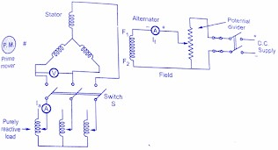

Open circuit test is done step by step from the following points,

1. The switch S is opened.
2. The [alternator](http://www.electricalengineeringinfo.com/2014/08/principle-and-working-of-synchronous-generator-alternator.html) is made to rotate using prime mover at synchronous speed and same speed is maintained constant throughout the test.
3. The excitation value is changed using a potential divider, from zero up to the rated value in a definite number of steps. The open circuit EMF is measured with the help of voltmeter. The readings are tabulated.
4. A graph of If and (Voc)ph i.e. field current and open circuit voltage per phase is plotted to some scale. This is open circuit characteristics.

2.Zero power factor test:

To conduct *zero power factor test*, the switch S is kept closed. Due to this, a purely inductive load gets connected to an [alternator](http://www.electricalengineeringinfo.com/2014/08/principle-and-working-of-synchronous-generator-alternator.html) through an ammeter. A purely inductive load has a power factor of cos 90° i.e. zero lagging hence the test is called zero power factor test.

The machine speed is maintained constant at its synchronous value. The

its rated full load value by varying excitation and by adjusting variable inductance of the inductive bad. Note that, due to purely inductive load, an [alternator](http://www.electricalengineeringinfo.com/2014/08/principle-and-working-of-synchronous-generator-alternator.html) will always operate at zero power factor lagging.

Key Point: *In this test, there is no need to obtain a number of points to obtain the curve. Only two points are enough to construct a curve called zero power factor saturation curve.*

The below is the graph of terminal voltage against excitation when delivering full load zero power factor current. One point for this curve is zero terminal voltage (short circuit condition) and the field current required to deliver full load short circuit armature current. While other point field current required to obtain rated terminal voltage while delivering rated full load armature current. With the help of these two points, the zero power factor saturation curve can be obtained as

1. Plot open circuit characteristics on a graph paper as shown in the below figure.
2. Plot the excitation corresponding to zero terminal voltage i.e. short circuit full zero power factor armature current. This point is shown as A in the below figure which the x-axis. Another point is the rated voltage when the [alternator](http://www.electricalengineeringinfo.com/2014/08/principle-and-working-of-synchronous-generator-alternator.html) is delivering full current at zero p.f. lagging. This point is P as shown in the below figure.

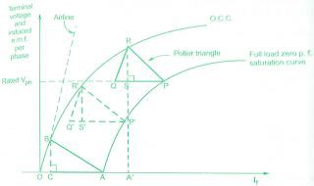

1. Draw the tangent to O.C.C. through origin which is line OB as shown dotted in below figure. This is called the airline.
2. Draw the horizontal line PQ parallel and equal to OA.
3. From the point, Q draw the line parallel to the airline which intersects O.C.C. at point R. Join RQ and join PR. The triangle PQR is called Potier triangle.
4. From point R, drop a perpendicular on PQ to meet at point S.
5. The zero power factor full load saturation curve is now be constructed by moving triangle PQR so that R remains always on OCC and line PQ always remains horizontal. The dotted triangle is shown in the above figure. It must be noted that the Potier triangle once obtained is constant for a given armature current and hence can be transferred as it is.
6. Though point A, draw a line parallel to PR meeting OCC at point B. From B, draw a perpendicular on OA to meet it at point C. Triangles OAB and PQR are similar triangles.
7. The perpendicular RS gives the voltage drop due to the armature leakage reactance

i.e. IXL

1. The length PS gives field current necessary to overcome the demagnetising effect of armature reaction at full load.
2. The length SQ represents field current required to induce an EMF for balancing leakage reactance drop RS. These values can be obtained from any Potier triangle such as OAB, PQR and so on.

So armature leakage reactance can be obtained as,

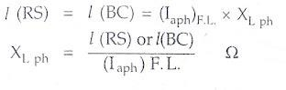

This is nothing but the Potier reactance.

Use of Potier reactance to determine regulation of alternator:

To determine regulation using Potier reactance, draw the phasor diagram using the following procedure:

1. Draw the rated terminal voltage Vph as a reference phasor. Depending upon at which power factor (cos Φ) the regulation is to be predicted, draw the Current phasor Iph lagging or leading Vph by angle Φ.
2. Draw Iph Raph voltage drop to Vph which is in phase with Iph. While the voltage drop Iph XLph is to be drawn perpendicular to Iph Raph, vector but leading Iph Raph at the extremity of Vph.
3. The Rph is to be measured separately by passing a d.c current and measuring the voltage across armature winding. While XLph is *Potier reactance* obtained by Potier method.

Phasor sum of Vph rated, Iph Raph and Iph XLph gives the e.m.f. which is say E1ph.

E1ph = Vph +Iph Raph +Iph XLph

1. Obtain the excitation corresponding to E1ph from OCC which is drawn. Let this excitation be Ff1. This is excitation required for inducing EMF which does not consider the effect of armature reaction.
2. The field current required to balance armature reaction can be obtained from Potier triangle method, which is say FAR.

FAR = I (PS) = I (AC) ........

1. The total excitation required is the vector sum of the Ff1 and FAR. This can be obtained exactly similar to the procedure used in [MMF method](https://www.electricalengineeringinfo.com/2016/12/mmf-ampere-turn-method-for-determining-voltage-regulation-alternator.html).
2. Draw vector Ff1 to some scale, leading E1ph by 90°. Add FAR to Ff1 by drawing vector FAR in phase opposition to Iph. The total excitation to be supplied by field is given by FR.

The complete phasor diagram is shown in the below figure:

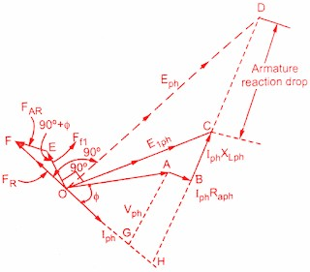

Once the total excitation is known which is FR, the corresponding induced emf Eph can be obtained from OCC. This Eph lags FR by 90°. The length CD drops due to the armature reaction. Drawing perpendicular from A and B on current phasor meeting at points G and H respectively, we get triangle OHC as right-angle triangle. Hence E1ph can be determined, analytically also. Once Eph is known, the regulation of an alternator can be predicted as,

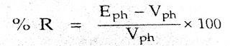

ZPF method takes into consideration the armature resistance and leakage reactance voltage drops as EMF quantities and the effect of armature reaction as MMF quantity. This is the reality hence the results obtained by this method are nearer to the reality the those obtained by [synchronous impedance](http://www.electricalengineeringinfo.com/2014/11/voltage-regulation-of-synchronous-generator-alternator-using-synchronous-impedance-method.html) [method](http://www.electricalengineeringinfo.com/2014/11/voltage-regulation-of-synchronous-generator-alternator-using-synchronous-impedance-method.html) and [ampere-turns method](http://www.electricalengineeringinfo.com/2016/12/mmf-ampere-turn-method-for-determining-voltage-regulation-alternator.html). The only drawback of the ZPF method is that the separate curve for every load condition is necessary to plot if Potier triangles for various load conditions are required.

1. Explain why the potier reactance is slightly higher than leakages reactance
2. Explain dark lamp method of synchronizing an alternator with the bus bar.

Before operating an alternator or synchronous generator in parallel to share the load with other already existing alternators. The connections ( in aspects of terminal voltage, frequency, phase sequence ) of the newly added alternator with the busbars of other alternators in parallel operation must be checked properly, this process is called 'Synchronization of Alternators'.

* + By varying the field excitation the generated terminal voltage of the generator or alternator can be varied.
  + The synchronization of frequency is done by controlling the speed of the prime mover that drives the alternator.
  + For synchronizing the phase sequence of the alternator the following methods can be used,
    - By using a phase sequence indicator.
    - By lamps method.
    - By using a [synchroscope](https://www.electricaldeck.com/2020/12/synchroscope-synchronization-of-alternator-or-ac-generator.html).

Synchronization by Lamps Method :

Dark Lamp Method (For Single-phase Alternators) :

Consider alternator B is to be connected to bus-bars, to which alternator A is already connected as shown in the figure below. The prime-mover of alternator B is brought up to its rated speed. The alternator is then excited and voltage is raised to that of bus-bars or alternator A voltage. If the frequencies of the alternators A and B are same and their terminal voltages are in phase opposition, no resultant voltage act across the lamps L1 and L2, and therefore these lamps remain dark.

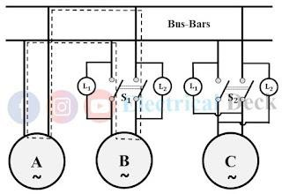

If the frequencies of the alternators A and B are not equal, the current through the lamps and local series circuit ( shown with dotted line ) will be changing, resulting in the flickering of lamps. The frequency will be changing, resulting in the flickering of lamps. The frequency of flickering is equal to ( fA ~ fB ). At this condition, lamps will glow up alternately. In the middle of the dark, the two voltages will be in-phase opposition with respect to the local circuit.

The speed of the alternator B is adjusted until the flickering of lamps is very slow. The voltage is also made equal to the incoming bus-bar voltage by changing field excitation. Now the switch S1 is closed in the middle of the dark period of the flickering lamps. Hence it is known as the dark lamp method.

Bright Lamp Method :

It is somewhat easier to judge the middle of the bright period than the middle of the dark period and some engineers prefer to synchronize with the bright lamp method. This necessitates the crossing over of the lamp connections, as in the case of another alternator C. Now, the lamps will glow brightest when the two voltages are in phase with the bus-bar because then the voltage across them is twice the voltage of each alternator.

Two Bright One Dark Lamp Method (For Three-phase Alternators) :

In addition to the condition discussed for single-phase alternators, it is necessary that the phase sequence of the incoming three-phase alternator must be the same as that of bus-bars ( RYB ) and, synchronization of one phase results in automatic synchronization of the other two phases.

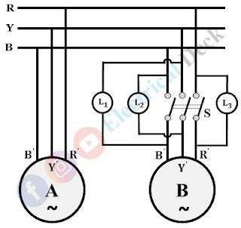In synchronization of three-phase alternators, the connection of three lamps ( for each phase ) must be done as shown in the below figure. Once the lamp is connected between the same phases while the other two are in cross-connection with the bus- bar phases. The phase sequence is synchronized on a particular sequence of alternatively varying brightness of three lamps. For perfect synchronization, the switch is closed when lamp L1 is dark while lamps L2 and L3 are equally bright.

When the incoming alternator B is in synchronism with alternator A or bus-bars, lamps L1, L2 are bright and L3 is dark ( since L1 is connected between YB', L2 between BY' and L3 between RR'). Since near the synchronism, the brightness of L1, L2 increases and of other L3 decreases, so the instant at which the incoming alternator is in synchronism with the bus-bars can be accurately determined, and switch S should be closed at this instant. This method of synchronization is known as the 'Two Bright and One Dark Lamp' method.

The voltage star RYB refers to the bus-bars and R' Y' B' to the incoming alternator

B. Then the instantaneous voltages across the three lamps are given by the vectors YB', Y'B, and RR'. When the frequency of the incoming alternator is same as that of the bus-bars, both vector diagrams rotate in space with the same angular velocity.

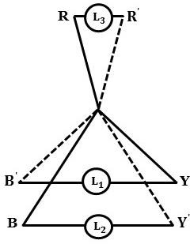Suppose the incoming alternator is too slow, then diagram R' Y' B' will rotate more slowly than RYB so that at the instant represented in below phasor figure YB' is increasing, Y'B is decreasing and RR' is increasing. If the incoming machine is too fast, then YB' is decreasing, Y'B increasing and RR' is decreasing.

Hence, if the three lamps are placed in a ring fashion a wave of light will travel in a clockwise or counter-clockwise direction around the ring according to the incoming alternator is fast or slow and also determines whether the speed must be decreased or increased. The switch is closed when the changes in light are very slow and at the instant L1 is dark. Lamp synchronizers are suitable only for low voltage alternators due to the limitation of lamp ratings.

1. Explain Blondel’s two-reaction theory.

Two Reaction Theory was proposed by Andre Blondel. The theory proposes to resolve the given armature MMFs into two mutually perpendicular components, with one located along the axis of the rotor of the salient pole. It is known as the direct axis or d axis component. The other component is located perpendicular to the axis of the rotor salient pole. It is known as the quadrature axis or q axis component.

The d axis component of the armature MMF, Fa is denoted by Fd, and the q axis component by Fq. The component Fd is either magnetizing or demagnetizing. The component Fq results in a cross-magnetizing effect. If Ψ is the angle between the armature current Ia and the excitation voltage Ef and Fa is the amplitude of the armature MMF, then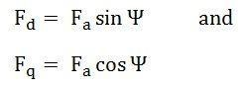

Salient Pole Synchronous Machine Two Rection Theory

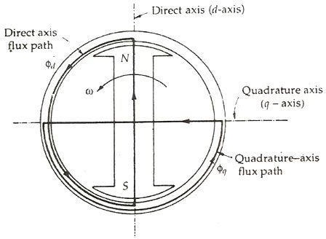In the cylindrical rotor synchronous machine, the air gap is uniform. The pole structure of the rotor of a salient pole machine makes the air gap highly non-uniform. Consider a 2 pole, salient pole rotor rotating in the anticlockwise direction within a 2 pole stator as shown in the figure below:

The axis along the axis of the rotor is called the direct or the d axis. The axis perpendicular to the d axis is known as the quadrature or q axis. The direct axis flux path involves two small air

gaps and is the path of the minimum reluctance. The path shown in the above figure by ϕq has two large air gaps and is the path of the maximum reluctance.

The rotor flux BR is shown vertically upwards as shown in the figure below:

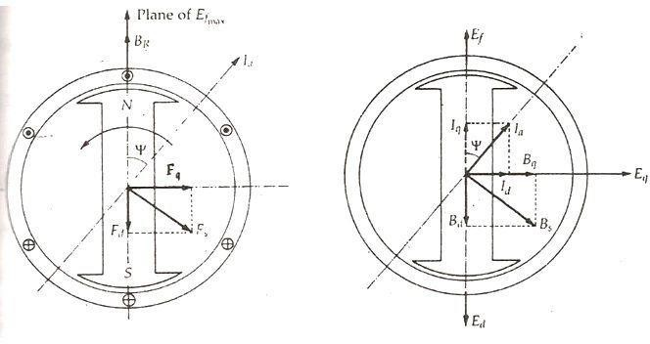 The rotor flux induces a voltage Ef in the stator. The stator armature current Ia will flow through the synchronous motor when a lagging power factor load is connected to it. This stator armature current Ia lags behind the generated voltage Ef by an angle Ψ.

The armature current produces stator magnetomotive force Fs. This MMF lags behind Ia by angle 90 degrees. The MMF FS produces stator magnetic field BS long the direction of Fs. The stator MMF is resolved into two components, namely the direct axis component Fd and the quadrature axis component Fq.

If,

* ϕd is the direct axis flux
* Φq is the quadrature axis flux
* 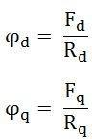Rd is the reluctance of the direct axis flux path

Therefore

As, Rd < Rq, the direct axis component of MMF Fd produces more flux than the quadrature axis component of the MMF. The fluxes of the direct and quadrature axis produce a voltage in the windings of the stator by armature reaction.

Let,

* Ead be the direct axis component of the armature reaction voltage.
* Eaq be the quadrature axis component of the armature reaction voltage.

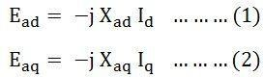Since each armature reaction voltage is directly proportional to its stator current and lags behind by 90 degrees angles. Therefore, armature reaction voltages can be

written as shown below: Where,

* Xad is the armature reaction reactance in the direct axis per phase.
* Xaq is the armature reaction reactance in the quadrature axis per phase.

The value of Xad is always greater than Xaq. As the EMF induced by a given MMF acting on the direct axis is smaller than for the quadrature axis due to its higher reluctance.

The total voltage induced in the stator is the sum of EMF induced by the field excitation. The equations are written as follows:

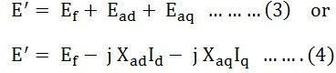

The voltage E’ is equal to the sum of the terminal voltage V and the voltage drops in the resistance and leakage reactance of the armature. The equation is written as:

The armature current is divided into two components; one is the phase with the excitation voltage Ef and the other is in phase quadrature to it.

If

* Iq is the axis component of Ia in phase with Ef.
* Id is the d axis Ia lagging Ef by 90 degrees.

Therefore, 

Combining the equation (4) and (5) we get,



Combining the equation (6) and (7) we get,

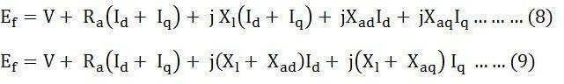

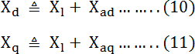Let,

The reactance Xd is called the direct axis synchronous reactance, and the reactance Xq is called the quadrature axis synchronous reactance.

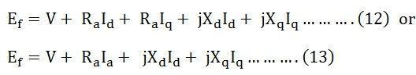Combining the equations (9) (10) and (11), we get the equations shown below:

The equation (12) shown above is the final voltage equation for a salient pole synchronous generator.

1. Explain how will you determine the d and q axes reactance of a synchronous machine in your laboratory.
2. Derive an expression for synchronizing power.

Synchronizing Power is defined as the difference between input power to alternator at power angle 𝛿 and input power to [alternator](http://www.electricalengineeringinfo.com/2014/08/principle-and-working-of-synchronous-generator-alternator.html) at power angle 𝛿 + 𝛿'.Synchronizing Power is denoted by PSY.

Consider an [alternator](http://www.electricalengineeringinfo.com/2014/08/principle-and-working-of-synchronous-generator-alternator.html) connected to the infinite bus bar. Let V be the bus bar voltage and E be the EMF induced in the alternator.The excitation of the [alternator](http://www.electricalengineeringinfo.com/2014/08/principle-and-working-of-synchronous-generator-alternator.html) is adjusted in such a way that E and V are equal in magnitude.In the local circuit, the two voltages E and V are in phase opposition while in the external circuit they are in the same phase.This is represented in the below figure.

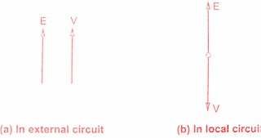

Must Read:

* + [Principle and working of Synchronous generator or alternator](http://www.electricalengineeringinfo.com/2014/08/principle-and-working-of-synchronous-generator-alternator.html)

Consider the [alternator](http://www.electricalengineeringinfo.com/2014/08/principle-and-working-of-synchronous-generator-alternator.html) to be at no load. If by some means power input to the machine is decreased and it's induced EMF E will then lag behind V by say angle 2𝛿.Due to this difference, E and V will not remain in exact phase opposition but will give rise to resultant EMF Er.This ER will act in the local circuit and a synchronizing current will start flowing in the local circuit.The synchronizing current is given by,

ISY = Er/Zs

Isy is lagging behind Er by an angle θ given by

θ = tan⁻¹(Xs/R)

R is very very small it can be neglected.

θ ≈ 90°

The angle 2𝛿 is very very small and θ is approximately equal to 90° so the synchronizing current Isy is almost in phase with V and in phase opposition with E.So infinite bus bar will deliver some power to the alternator.As the current in the local circuit is always opposing to induced EMF E, the [alternator](http://www.electricalengineeringinfo.com/2014/08/principle-and-working-of-synchronous-generator-alternator.html) will act as a [synchronous motor](http://www.electricalengineeringinfo.com/2016/12/construction-working-principle-synchronous-motor-applications.html).

Thus synchronizing torque will be developed which will try to accelerate the machine. Thus the angle 2𝛿 will go on decreasing and resultant EMF Er also goes on decreasing. Finally, the two EMF's E and V will again be in phase opposition and the machine will now act as an alternator in synchronism with the bus bar.

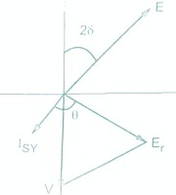

Thus the power which automatically comes into play and accelerates the machine which was retarding and decelerates the machine which tries to accelerate is called synchronizing power. This power will keep the machine in step with the infinite bus bar.

This textbook "Electrical Machinery by P.S. Bhimbhra" is the best in industry. Grab it now for very less price.

Expression for Synchronizing Power(PSY):

Consider an [alternator](http://www.electricalengineeringinfo.com/2014/08/principle-and-working-of-synchronous-generator-alternator.html) which is operating at a power angle 𝛿 i.e. E leads V by an angle 𝛿.

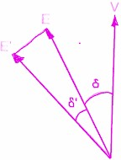

Let power input of this [alternator](http://www.electricalengineeringinfo.com/2014/08/principle-and-working-of-synchronous-generator-alternator.html) be increased suddenly so that it will now operate at a new power angle given by 𝛿 + 𝛿'.So the synchronizing emf ESY will come into play and sends a circulating current given by ISY = ESY/Zs. This current produces synchronizing power. Now we will derive the expression for *synchronizing power* per phase.

Before increasing the input of [alternator](http://www.electricalengineeringinfo.com/2014/08/principle-and-working-of-synchronous-generator-alternator.html), the power input Pi1 is given by,



When power angle 𝛿 has changed to 𝛿±𝛿′ (+ sign indicates acceleration and - sign indicates deceleration) the power input Pi2 is given by



The difference between these two powers is nothing but synchronizing power PSY.

PSY = Pi2 - Pi1

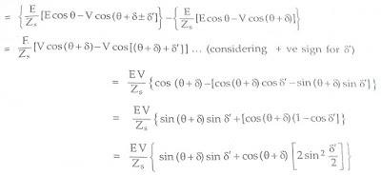

If 𝛿′ is small then 𝛿′/2 is very very small. Therefore sin²(𝛿′/2) can be neglected as it is tending towards zero.



For large [synchronous machines](http://www.electricalengineeringinfo.com/2014/08/principle-and-working-of-synchronous-generator-alternator.html) θ = 90° and Zs = Xs as Ra is neglected



For [synchronous generator](http://www.electricalengineeringinfo.com/2014/08/principle-and-working-of-synchronous-generator-alternator.html) which is synchronized with bus bar V = E, 𝛿 = 0 and 𝛿′ is very very small.

Sin 𝛿′ = 𝛿′ and Cos 𝛿 = 1



The above expression is per phase power. Therefore for the machine having 'm' phases the synchronizing power is given by,



Expression for Synchronizing Power in Salient pole machine:

The same expression is not valid for salient pole machine. The expression for salient pole machine can be obtained as follows:

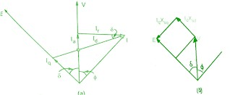

From figure(a), it can be observed that

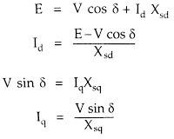

From figure(b), it can be observed that

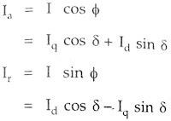

Must Read:

* + [Zero power factor or Potier triangle method for regulation of alternator](http://www.electricalengineeringinfo.com/2016/12/zero-power-factor-zpf-potier-triangle-method-regulation-alternator.html)

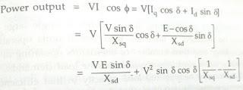

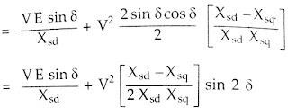



Thus the total power consists of a fundamental component and a second harmonic component which is present because the armature reaction flux has a tendency to pass through the field structure along its minimum reluctance path i.e. along field pole axis and direct axis.

Since 2𝛿 exists because of difference in reluctance along p and q axes and is called reluctance power and the term is called reluctance torque. The first term is

identical with that obtained for the cylindrical machine and component of power is known as electromagnetic power.

Now dP/d𝛿 gives the Synchronizing power.





1. For a salient pole synchronous machine, derive an expression for power developed as a function of load angle.
2. Explain the operating principle of three-phase alternator.

The working of an alternator is based on the principle that when the flux linking a conductor changes, an emf is induced in the conductor.

An alternator has 3,-phase winding on the stator and a DC field winding on the rotor. This DC source (called exciter) is generally a small DC shunt or compound generator mounted on the shaft of the alternator.

Rotor construction is of two types, namely;

1. Salient (or projecting) pole type
2. Non-salient (or cylindrical) pole type

In salient pole type alternator, salient or projecting poles are mounted on a large circular steel frame which is fixed to the shaft of the alternator.

In cylindrical pole type alternator, the rotor is made of a smooth solid forged-steel radial cylinder having a number of slots along the outer periphery.

The rotor winding is energized from the DC exciter and alternate N and S poles are developed on the rotor.

When the rotor is rotated in the anti-clockwise direction by a prime mover, the stator or armature conductors are cut by the magnetic flux of rotor poles. Consequently,

e.m.f. is induced in the armature conductors due to electromagnetic induction.

The induced e.m.f. is alternating since N and S poles of rotor alternately pass the armature conductors. The direction of induced e.m.f. can be found by Fleming right- hand rule and frequency is given by;

f = PN / 120

where N = speed of the rotor in r.p.m. P = number of rotor poles

The magnitude of the voltage induced in each phase depends upon the rotor flux, the number and position of the conductors in the phase and the speed of the rotor.

When the rotor is rotated, a 3-phase voltage is induced in the armature winding. The magnitude of induced e.m.f. depends upon the speed of rotation and the DC exciting current. The magnitude of e.m.f. in each phase of the armature winding is the same. However, they differ in phase by 120° electrical.

1. Explain the constructional details of a three-phase alternator, which is used for slow speed operation.
2. State requirements for paralleling alternators.

Alternators are paralleled for the same reasons that make it necessary to parallel dc generators. Two alternators are paralleled whenever the power demand of the load circuit is greater than the power output of a single alternator.

When dc generators are paralleled, it is necessary to match the output voltage and electrical polarity of the machines with the voltage and polarity of the line. The same matching is required when alternators are paralleled. However, the matching of alternator polarity to that of the line presents problems not encountered when matching dc generator and line polarities. The output voltage of an alternator is continuously changing in both magnitude and polarity at a definite frequency. Thus, when two alternators are paralleled, not only must the rate of the rise and fall of voltage in both alternators be equal, but the rise and fall of voltage in one machine must be exactly in step with the rise and fall of voltage in the other machine. When two alternators are in step, they are said to be in synchronism. Alternators cannot be paralleled until their voltages, frequencies, and instantaneous polarities are exactly equal.

Fig. 13-1 shows a comparison of the voltage curves of one of the phases of two three- phase generators operating independently but at different speeds. The voltage curves must be in synchronism before paralleling machines.

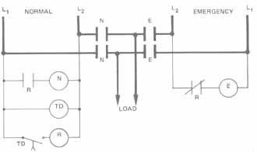

Fig. 13-1 Periodic time relationship of the out-of-phase voltages of two generators running at different speeds

The output voltage of an alternator can be controlled by varying the strength of the direct current in the field circuit of the alternator. A field rheostat can be used to vary the dc current. Since the frequency of an alternator varies directly with speed changes, it is necessary to be able to control the speed of at least one alternator in an installation containing two machines.

ACHIEVING SYNCHRONIZATION

To synchronize AC generators, several important factors must be checked.

1. The phase rotation of both generator systems must be the same. Check this with lights as described later or use a phase rotation meter to determine ABC or ACB rotation.
2. The AC voltages of both generators should be equal. In practice the voltage of the on-coming generator is usually 1-2 volts higher than that of the other operating generator.
3. The frequencies of the on-coming generators must match when synchronized. In practice the frequency of the on-coming generator is 1-2 hertz higher than that of the on-line generator. This can be observed with lights or by using a synchroscope.

The speed and output voltage of the on-coming generator are slightly higher to pre vent it from becoming a load to the system when it is connected.

PART II UNIVERSITY EXAM QUESTION PATTERN – 6 MARK (EACH QUESTION CARRIES 2 MARKS) ANSWER ALL QUESTION

* 1. What are the main parts of synchronous motor?

The stator and the rotor are the two main parts of the synchronous motor. The stator becomes stationary, and it carries the armature winding of the motor. The armature winding is the main winding because of which the EMF induces in the motor. The rotator carry the field windings. The main field flux induces in the rotor. The rotor is designed in two ways, i.e., the salient pole rotor and the non-salient pole rotor.

* 1. Explain why synchronous motor has no starting torque.
* when we apply three-phase voltage to the three-phase winding of stator, the current will flow through the winding, which sets up a synchronous rotating magnetic field across the stator in air gap as shown in Figure 1.

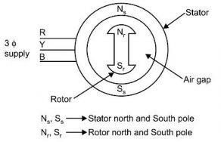

Figure 1: Simple synchronous motor Model

* This rotating magnetic field should produce torque in the stationary rotor. However, analyses of the rotating magnetic field on the rotor are shown in Figure 2.

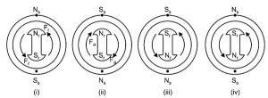

Figure 2: Effect of the rotating magnetic field of the stator

In the first case, the Rotor Nr pole of the rotor is aligned with the stator Ns pole, while Sr pole is aligned with the Sr pole of the stator. In this case, the rotor will experience a push due to repulsion between similar poles, and torque will produce in the rotor in an anticlockwise direction as highlighted in figure with the help of case (i). At the very next moment, due to the rotating magnetic field of the stator, the stator Ss pole will be aligned with Nr pole of the rotor and Ns pole of the stator will be aligned with Sr pole of rotor. In this case, due to opposite poles attraction, again there will be a force on rotor, resulting in equal torque but this time in the opposite direction as compared to the previous case. Therefore, in case (ii) rotor will experience clockwise torque. Thus, in every half cycle, torque direction is changing and the rotor in normal condition moves back and forth according to the direction of torque. However, due to its inertia, it does not respond that fast to the changing torque resulting in zero net effect and no movement of the rotor.

In order to start it, the rotor is first started with the help of some DC motor and speed is increased until it reaches a synchronous speed of stator. Then three-phase supply is applied on the stator to produce a magnetic field across it, and external power to the rotor is removed. The rotor is already rotating at synchronous speed, due to continuous change in direction of rotor poles at a similar rate with stator magnetic field; it will always experience unidirectional torque. Due to this magnetic field locking, the rotor will continue to move at synchronous speed in one direction due to unidirectional repulsion from the stator.

PART II

1. What are the main parts of synchronous motor?

A synchronous motor is generally made up of two parts, a stator the stationary part of the machine that carries the armature winding in which the voltage is generated,

and a rotor the rotating part of the machine that produces the main field flux.

Stator includes various parts like stator frame, stator core, stator windings, and cooling arrangement.

* 1. Stator Frame

It is the outer body of the machine made of cast iron, and it protects the inner parts of the machine.

* 1. Stator Core

The stator core is made of silicon steel material. It is made from many stamps which are insulated from each other. Its function is to provide an easy path for the magnetic lines of force and accommodate the stator winding.

* 1. Stator Winding

Slots are cut on the inner periphery of the stator core in which 3 phase or 1 phase winding is placed. Enameled copper is used as a winding material. The winding is star connected. The winding of each phase is distributed over several slots. When the current flows in a distributed winding it produces an essentially sinusoidal space distribution of EMF.

1. Rotor Construction

The rotating part of the machine is called the Rotor. There are two types of rotor construction, namely the salient pole type and the cylindrical rotor type. In the following, we will deal with each of these two types of rotors and you can find their differences in their structure and operation.

* 1. Salient Pole Rotor

The term salient means projecting. Thus, a salient pole rotor consists of poles projecting out from the surface of the rotor core. The end view of a typical 6 pole salient pole rotor is shown below in the figure.

Since the rotor is subjected to changing magnetic fields, it is made of steel laminations to reduce eddy current losses. Poles of identical dimensions are assembled by stacking laminations to the required length. A salient pole synchronous machine has a non-uniform air gap. The air gap is minimized under the pole centers and it is maximum in between the poles.

They are constructed for medium and low speeds as they have a large number of poles

1. Explain why synchronous motor has no starting torque.

Due to the inertia of the rotor, it is unable to rotate in the direction of anticlockwise torque, to which is the driving force or stator rotating field. Just in that instant, the stator poles change their positions. Consider an instant half a period later where stator poles are exactly reversed but due to inertia rotor is unable to rotate from its initial position. At this instant, due to the unlike poles trying to attract each other, the rotor will be subjected to torque in the clockwise direction.

This will tend to rotate the rotor in the direction of the rotating magnetic field. But, before this happens stator poles again change their position reversing the direction of the torque exerted on the rotor. Hence the average torque on the rotor is zero. So, synchronous motor will not start itself.

1. What is synchronous capacitor?

a synchronous condenser (sometimes called a syncon, synchronous capacitor or synchronous compensator) is a DC-excited [synchronous motor](https://en.wikipedia.org/wiki/Synchronous_motor), whose shaft is not connected to anything but spins freely.[[1]](https://en.wikipedia.org/wiki/Synchronous_condenser#cite_note-Weedy72-1) Its purpose is not to convert [electric power](https://en.wikipedia.org/wiki/Electric_power) to mechanical power or vice versa, but to adjust conditions on the [electric power transmission grid](https://en.wikipedia.org/wiki/Electric_power_transmission_grid). Its field is controlled by a voltage regulator to either generate or absorb [reactive power](https://en.wikipedia.org/wiki/Reactive_power) as needed to adjust the grid's [voltage](https://en.wikipedia.org/wiki/Voltage), or to improve [power factor](https://en.wikipedia.org/wiki/Power_factor). The condenser’s installation and operation are identical to large [electric motors](https://en.wikipedia.org/wiki/Electric_motor) and generators. Synchronous condensers are an alternative to [capacitor banks](https://en.wikipedia.org/wiki/Capacitor_bank) for [power-](https://en.wikipedia.org/wiki/Power-factor_correction) [factor correction](https://en.wikipedia.org/wiki/Power-factor_correction) in power grids. One advantage is the amount of reactive power from a synchronous condenser can be continuously adjusted. Reactive

power from a capacitor bank decreases when grid voltage decreases, while a synchronous condenser can increase reactive current as voltage decreases

1. Synchronous motor always runs at synchronous speed why
   * + Synchronous motors run at synchronous speed. The synchronous speed of a motor depends on the supply frequency and the number of poles in the [motor](https://www.electrical4u.com/electrical-motor-types-classification-and-history-of-motor/). Synchronous speed is given by

Where, f = supply frequency and p = number of poles. We can change the synchronous speed of the motor by changing the supply frequency and the number of poles. But the motor would always run with this speed for a given supply frequency and the number of poles.

* + - [Synchronous motors](https://www.electrical4u.com/synchronous-motor-working-principle/) have lots of advantages but being not self-starting unlike [3 phase induction motors](https://www.electrical4u.com/working-principle-of-three-phase-induction-motor/), is a major disadvantage. In synchronous motors, the stator has 3 phase windings and is excited by 3 phase supply whereas the rotor is excited by DC supply. The 3 phase windings provide rotating [flux](https://www.electrical4u.com/what-is-flux-types-of-flux/) whereas the DC supply provides constant flux.

1. What is hunting?

When the load applied to the synchronous motor is suddenly increased or decreased, the rotor oscillates about its synchronous position with respect to the stator field. This action is called hunting.

1. What are V-Curves?

V curve is the graph showing the relation of [armature current](https://en.wikipedia.org/wiki/Armature_(electrical_engineering)) as a function of [field](https://en.wikipedia.org/wiki/Stator) [current](https://en.wikipedia.org/wiki/Stator) in [synchronous machines](https://en.wikipedia.org/wiki/Synchronous_machine) keeping the load constant. The purpose of the curve is to show the variation in the magnitude of the [armature current](https://en.wikipedia.org/wiki/Armature_(electrical_engineering)) as the [excitation voltage](https://en.wikipedia.org/wiki/Excitation_(magnetic)) of the [machine](https://en.wikipedia.org/wiki/Electrical_machine) is varied.

1. What are the uses of damper windings in a synchronous motor?

The functions of Damper Windings are as follows :

* Damper windings helps the synchronous motor to start on its own (self starting machine) by providing starting torque
* By providing damper windings in the rotor of synchronous motor “Hunting of machine”can be suppressed.When there is change in load, excitation or change in other conditions of the systems rotor of the synchronous motor will oscillate to and fro about an equilibrium position. At times these oscillations becomes more violent and resulting in loss of synchronism of the motor and comes to halt

1. How do you operate the synchronous motor at any desired pf?

The great feature of Synchronous Motor is its ability to operate at leading power factor when over-excited. A Synchronous Motor can be made to operate at unity and leading power factor by just increasing its excitation voltage i.e. by increasing the field current. This advantage of Synchronous Motor is used to improve the power factor.

1. What will be the pf when the synchronous motor is operated at under excited conditions?
2. What are the different methods of starting synchronous motor?

The different methods used to start a synchronous motor are :

Using Pony Motors :

By using the small pony motors like a small induction motor, we can start the synchronous motor. This small induction motor is coupled to the rotor of the synchronous motor. The function of this induction motor is to bring the rotor of the synchronous motor to the synchronous speed.

Once the rotor attains the synchronous speed the pony motor is dis-coupled

supplying d.c. excitation to the rotor through the slip-rings. One should remember that the motor used as the pony motor must have less number of poles than the synchronous motor used.

Using Small D.C. Machine :

In the above method, we have a seen small induction motor to start the motor. Here we use d.c. motor instead of induction motor to bring the motor to synchronous motor.

Once the d.c. motor brings the rotor of the synchronous motor to synchronous speed. The motor starts acting as the [d.c. generator](https://www.electricaldeck.com/2020/01/working-principle-of-dc-generator.html) and starts giving excitation to the field winding of the synchronous motor.

Using Damper Winding :

When a 3-phase supply is given to the synchronous motor it fails to start. In order to make it start copper bars circuited at both ends ( similar to the squirrel cage rotor of an induction motor ) are placed on the rotor, these bars or winding are known as 'Damper Winding'.

Now when the supply is given the field winding setups a rotating magnetic field. Due to the damper winding used, the rotor starts rotating as an induction motor i.e., less than the synchronous speed at starting. Once d.c. excitation is given to the field winding and the motor is then pulled into synchronism.



The damper winding is used to start the motor and hence can be used for starting purposes only. Because once the rotor rotates at synchronous speed the relative motion between the damper winding and rotating magnetic will be equal, and hence induced [emf](https://www.electricaldeck.com/2020/04/emf-equation-of-synchronous-generator-or-alternator.html) and current will be zero. The damper winding will be out of the circuit.

PART IIA UNIVERSITY EXAM QUESTION PATTERN – 6 MARK (EACH QUESTION CARRIES 6 MARKS) ANSWER ANY 10 QUESTION

* 1. Explain why a synchronous motor does not have starting torque. Above a certain size, synchronous motors are not self-starting motors. This property is due to the inertia of the rotor; it cannot instantly follow the rotation of the magnetic field of the stator. Once the rotor nears the synchronous speed, the field winding is excited, and the motor pulls into synchronization.

To get a clear idea about the question “why a synchronous motor is not self- starting?” consider a rotating magnetic field as equivalent to the physical rotation of two stator poles N1 and S1. Assume any instant like that two poles are in line with the stator magnetic axis [A-B]. At this instant, rotor poles are arbitrarily positioned. When DC supply is given to stationary rotor unlike poles will try to attract each other. Because of this action, the rotor will be subjected to an instantaneous torque in an anticlockwise direction. As we connected the power supply to the stator, the stator poles will rotate at speed of Ns rpm.

Due to the inertia of the rotor, it is unable to rotate in the direction of anticlockwise torque, to which is the driving force or stator rotating field. Just in that instant, the stator poles change their positions. Consider an instant half a period later where stator poles are exactly reversed but due to inertia rotor is unable to rotate from its initial position. At this instant, due to the unlike poles trying to attract each other, the rotor will be subjected to torque in the clockwise direction.

This will tend to rotate the rotor in the direction of the rotating magnetic field. But, before this happens stator poles again change their position reversing the direction of the torque exerted on the rotor. Hence the average torque on the rotor is zero. So, synchronous motor will not start itself.

* 1. Explain one method of starting a synchronous motor.

When a 3-phase supply is given to the synchronous motor it fails to start. In order to make it start copper bars circuited at both ends ( similar to the squirrel cage rotor of an induction motor ) are placed on the rotor, these bars or winding are known as 'Damper Winding'.

Now when the supply is given the field winding setups a rotating magnetic field. Due to the damper winding used, the rotor starts rotating as an induction motor i.e., less than the synchronous speed at starting. Once d.c. excitation is given to the field winding and the motor is then pulled into synchronism.



The damper winding is used to start the motor and hence can be used for starting purposes only. Because once the rotor rotates at synchronous speed the relative motion between the damper winding and rotating magnetic will be equal, and hence induced [emf](https://www.electricaldeck.com/2020/04/emf-equation-of-synchronous-generator-or-alternator.html) and current will be zero. The damper winding will be out of the circuit.

* 1. Why does the power factor of industrial installation tend to be low? How can it be improved?
  2. Does the change in excitation affect the p.f of the synchronous motor?
  3. An over excited synchronous motor is called a synchronous condenser. Explain.
  4. Mention some specific applications of synchronous motor. Synchronous Motors are basically used for the following applications:
     1. Power Factor Correction
     2. Voltage Regulation
     3. Constant Torque and constant Speed Drive Synchronous Motor Applications:
* Synchronous motor is used as synchronous condenser for [power factor](https://electricalbaba.com/power-factor-improvement-correction-methods/) [correction or improvement](https://electricalbaba.com/power-factor-improvement-correction-methods/). Synchronous condenser is an over-excited synchronous motor without having any mechanical load connected to its shaft. A synchronous condenser when connected to supply mains takes leading current and hence delivers the reactive power. This reactive power delivered by the synchronous condenser is absorbed by the connected induction motors and thus the supply line is relieved from carrying reactive power. In this way, the overall power factor is improved. Use of synchronous condenser for power factor improvement is advantageous as the amount of reactive power generation can varied by the adjustment of field excitation. This is not possible with static capacitors. For detail, please read “[How](https://electricalbaba.com/how-synchronous-motor-improves-the-power-factor/) [Synchronous Motor Improves the Power Factor?](https://electricalbaba.com/how-synchronous-motor-improves-the-power-factor/)”
* It is used at the end of transmission line for voltage regulation. Though this method is obsolete now and various electronic devices like [STATCOM](https://electricalbaba.com/statcom-working-principle-design-and-application/) are employed for this purpose.
* Due to higher efficiency as compared to 3 phase induction motor and constant speed irrespective of load variation, it is used for constant speed drives. Some typical applications of synchronous
* A synchronous motor is also used in household applications. It is used in microwave oven, clock, tape players etc. In microwave oven, it is used to rotate the turn table.
  1. Explain what happens when the load on a synchronous motor is changed.

A synchronous motor runs at constant synchronous speed, regardless of the load. Let us see the effect of the load change on the motor. Consider a synchronous motor operating initially with a leading power factor. The phasor diagram for the leading power factor is shown below:

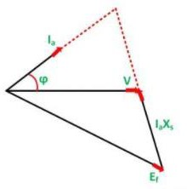

The load on the shaft is increased. The rotor slows down momentarily, as it required some time to take increased power from the line. In another word, it can be said that even if the rotor is rotating at synchronous speed, the rotor slips back in space because of the increase in the load. In this process, the torque angle δ becomes larger, and, as a result, the induced torque increases.

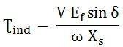The induced torque equation is given as:

Then increased torque increases the rotor speed, and the motor again regains the synchronous speed, but with the larger torque angle. The excitation voltage Ef is proportional to ϕω, it depends upon the field current and the speed of the motor. Since the motor is moving at a synchronous speed, and the field current is also

constant. Hence, the magnitude of the Voltage |Ef| remains constant. We have,

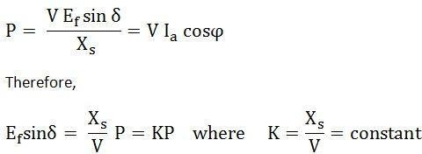

From the above equations, it is clear, that if P is increased the value of Ef sinδ and Ia cosϕ also increases.

The figure below shows the effect of an increase in load on the operation of a synchronous motor.

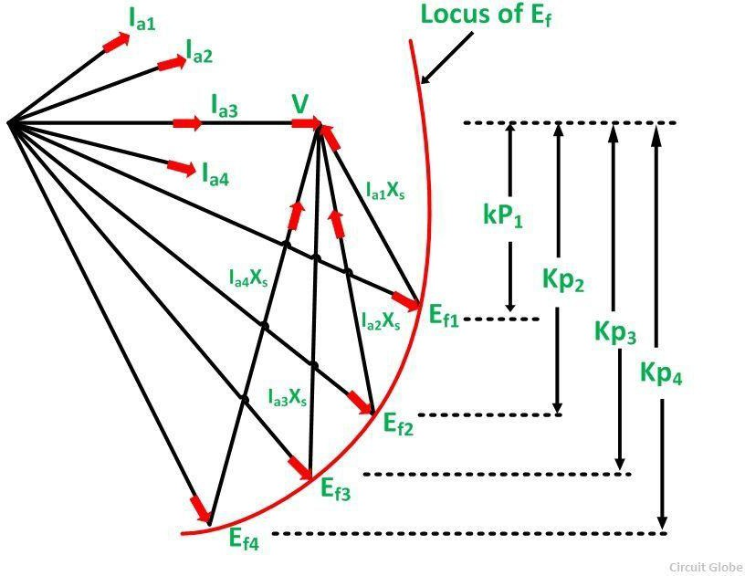

It is seen from the above figure that with the increase in load, the quantity jIaXs goes on increasing and the relation V = Ef + jIaXs is satisfied. The armature current is also

increased. The power factor angle also changes with the change in load. It becomes less and less leading and then becomes more and more lagging as shown in the figure above.

Thus, if the load on a synchronous motor is increased the following points are considered which are given below.

* The motor continues to run at synchronous speed.
* The torque angle δ increases.
* The excitation voltage Ef remains constant.
* The armature current Ia drawn from the supply increases.
* The phase angle ϕ increases in the lagging direction.

There is a limit to the mechanical load that can be applied to a synchronous motor. As the load is increased, the torque angle δ also increases until the condition arises when the rotor is pulled out of synchronism and the motor is stopped.

Pull-out torque is defined as the maximum value of the torque which a synchronous motor can develop at rated voltage and frequency without losing synchronism. Its values vary from 1.5 to 3.5 times the full load torque.

* 1. What is meant by constant power circle for synchronous motor?
  2. What is meant by hunting in a synchronous motor? Why is it undesirable? What is done to minimize it?
  3. Explain V-curves and inverted V-curves.

The performance characteristics of a [synchronous motor](https://www.electricaldeck.com/2020/04/working-principle-of-synchronous-motor-starting-methods-and-applications.html) are obtained by v-curves and inverted v-curves. Synchronous machines have parabolic type characteristics ( the graph drawn is in the shape of parabolic ). If the excitation is varied from low ( under-excitation ) to high ( over-excitation ) value, then the current Ia also changes i.e., becomes minimum at unity p.f. and then again increases. But at starting lagging current becomes unity and then becomes leading in nature. V-curves and inverted V-curves of a synchronous motor are used to analyze efficiency on no-load and on- load conditions.

V-Curves of Synchronous Motor :

If the armature current Ia is plotted against excitation or field current for various load conditions, we obtain a set of curves known as 'V-Curves' clue to their shape similar to english letter V.

In the below figure V-Curve of a synchronous motor shows how armature current Ia changes with excitation for the same input, at no-load, half full-load, and full-load.

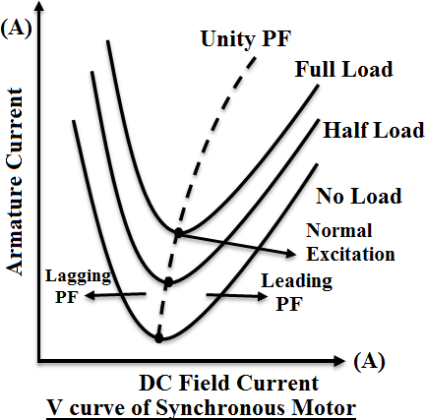

From V-Curves it is observed that the armature current has large values both for low and high values of excitation ( though it is lagging for low excitation and leading for higher excitation ). In between, it has a minimum value corresponding to the unity power factor ( normal excitation ).

Inverted V-Curves of Synchronous Motor :

If the power factor is plotted against excitation for various load conditions, we obtain a set of curves known as 'Inverted V-Curves'.

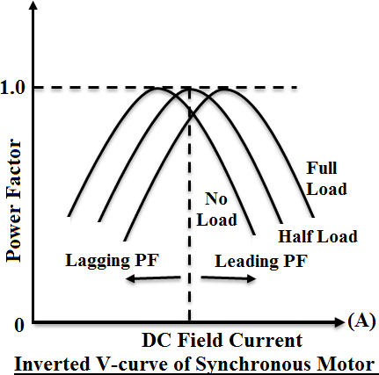

The inverted V-Curves of synchronous motor shows how the [power factor](https://www.electricaldeck.com/2020/04/synchronous-condenser-and-power-factor-correction.html) [varies](https://www.electricaldeck.com/2020/04/synchronous-condenser-and-power-factor-correction.html) with excitation. From inverted V-curves, it is observed that the power factor is lagging when the motor is under excited and leading when it is over-excited. In between, the power factor is unity.

1. Draw the power angle diagram of a synchronous machine.

Consider a synchronous machine connected to an infinite bus through a transmission line of reactance Xl shown in a figure below. Let us assume that the resistance and capacitance are neglected.

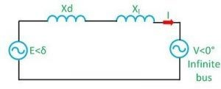

Equivalent diagram of synchronous machine connected to an infinite bus through a transmission line of series reactance Xl is shown below:

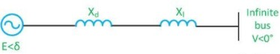

Let,

V = V<0⁰ – voltage of infinite bus E = E<δ – voltage behind the direct axis synchronous reactance of the machine. Xd = synchronous / transient resistance of the machine

The complex power delivered by the generator to the system is S = VI

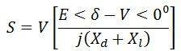

Let,

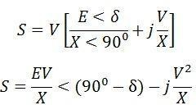 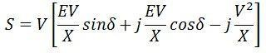

system

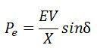

δ = 0

Active power transferred to the

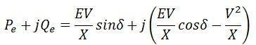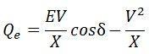The reactive power transferred to the system

The maximum steady-state power transfers occur when

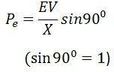

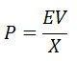The graphical representation of Pe and the load angle δ is called the power angle curve. It is widely used in power system stability studies. The power angle curve is shown below

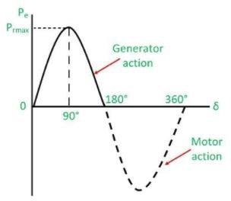

Maximum power is transferred when δ = 90⁰. As the value of load angle δ is above 90, Pe decrease and becomes zero at δ = 180⁰. Above 180⁰, Pe becomes negative, which show that the direction of power flow is reversed, and the power is supplied from infinite bus to the generator. The value of Pe is often called pull out power. It is also called the steady-state limit.

The total reactance between two voltage sources E and X is called the transfer reactance. The maximum power limit is inversely proportion to the transfer reactance.

1. Explain briefly the principle of operation of three-phase synchronous motor. Synchronous motor works on the principle of the magnetic locking. When two unlike poles are brought near each other, if the magnets are strong, there exists a tremendous force of attraction between those two poles. In such condition the two magnets are said to be magnetically locked.

If now one of the two magnets is rotated, the other also rotates in the same direction, with the same speed due to the force of attraction i.e. due to magnetic locking condition.

So to have the magnetic locking condition, there must exist two unlike poles and magnetic axes of two must be brought very close to each other. Let us see the application of this principle in case of synchronous motor.

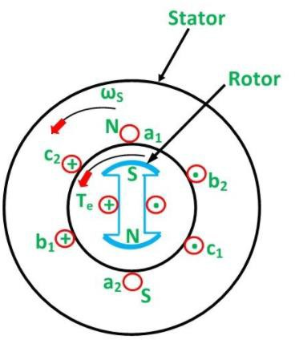

Consider a three phase synchronous motor, whose stator is wound for 2 poles. The two magnetic fields are produced in the synchronous motor by exciting both the windings, stator and rotor with three phase a.c. supply and d.c. supply respectively. When three phase winding is excited by a three phase a.c. supply the the flux produced by the three phase winding is always of rotating type, which is already discussed in the previous post. Such a magnetic flux rotates in space at a speed called synchronous speed. This magnetic field is called rotating magnetic field. The rotating magnetic field creates the effect similar to the physical rotation of magnets in space with a synchronous speed. So stator of the synchronous motor produces one magnet which is as good as rotating in space with the synchronous speed. The synchronous speed of a stator rotating magnetic field depends on the supply frequency and the number of poles for which stator winding is wound. if the frequency of the a.c. supply is f Hz and stator is wound for P number of poles, then the speed of the rotating magnetic field is synchronous given by,

Ns = 120f/P r.p.m.

In this case, as stator is wound for say 2 poles, with 50 Hz supply, the speed of the rotating magnetic field will be 3000 r.p.m. This effect is similar to the physical rotation of two poles with a speed of Ns r.p.m. For simplicity of understanding let us assume that the stator poles are N1 and S1 which are rotating at a speed of Ns. The direction of rotation of rotating magnetic field is say clockwise.

When the field winding on rotor is excited by a d.c. supply, it also produces two poles, assuming rotor construction to be two pole, salient type. Let these poles be N2 and S2.

Now one magnet is rotating at Ns having poles N1 and S1 while at start rotor is stationary i.e. second magnet is stationary having poles N2 and S2. If somehow the unlike poles N1 and S2 or S1 and N2 are brought near each other, the magnetic locking may get established between stator and rotor poles. As stator poles are rotating due to magnetic locking rotor will also rotate in the same direction as that of stator poles

i.e. in the direction of rotating magnetic field, with the same speed i.e Ns. Hence synchronous motor rotates at one and only one speed i.e. synchronous speed. But this all depends on existence of magnetic locking between stator and rotor poles. Practically it is not possible for stator poles to pull the rotor poles from their stationary position into magnetic locking condition. hence synchronous motors are not self starting. Let us see the reason behind this in detail.

1. Describe the effect of varying the excitation on the armature current and power factor of a synchronous motor when input power to the motor is maintained constant.

PROFESSIONAL ENGINEERING CREDITS ASSESSMENT & EVALUATION

PART III UNIVERSITY EXAM QUESTION PATTERN – 6 MARK (EACH QUESTION CARRIES 2 MARKS) ANSWER ALL QUESTION

* 1. Name the two type of rotor of an induction motor?

There are two designs for the rotor in an induction motor: squirrel cage and wound. In generators and alternators, the rotor designs are [salient](https://en.wikipedia.org/wiki/Salient_pole) [pole](https://en.wikipedia.org/wiki/Salient_pole) or [cylindrical](https://en.wikipedia.org/wiki/Cylindrical).

The [squirrel-cage rotor](https://en.wikipedia.org/wiki/Squirrel-cage_rotor) consists of laminated [steel](https://en.wikipedia.org/wiki/Steel) in the core with evenly spaced bars of copper or [aluminum](https://en.wikipedia.org/wiki/Aluminum) placed [axially](https://en.wikipedia.org/w/index.php?title=Axially&action=edit&redlink=1) around the periphery, permanently shorted at the ends by the end rings.[[3]](https://en.wikipedia.org/wiki/Rotor_(electric)#cite_note-induction-3) This simple and rugged construction makes it the favorite for most applications. The assembly has a twist: the bars are [slanted](https://en.wikipedia.org/w/index.php?title=Slanted&action=edit&redlink=1), or skewed, to reduce magnetic hum and slot harmonics and to reduce the tendency of locking. Housed in the stator, the rotor and stator teeth can lock when they are in equal number and the magnets position

mount the rotor in its housing, with one end of the shaft protruding to allow the attachment of the load. In some motors, there is an extension at the [non-driving](https://en.wikipedia.org/w/index.php?title=Non-driving&action=edit&redlink=1) end for [speed sensors](https://en.wikipedia.org/wiki/Speed_sensors) or other [electronic controls](https://en.wikipedia.org/w/index.php?title=Electronic_controls&action=edit&redlink=1). The generated torque forces motion through the rotor to the load.

In the wound rotor, the rotor is a [cylindrical](https://en.wikipedia.org/wiki/Cylindrical) core made of steel lamination with slots to hold the wires for its 3-phase windings which are evenly spaced at 120 electrical degrees apart and connected in a 'Y' configuration.[[4]](https://en.wikipedia.org/wiki/Rotor_(electric)#cite_note-4) The rotor winding terminals are brought out and attached to the three slips rings with brushes, on the shaft of the rotor.[[5]](https://en.wikipedia.org/wiki/Rotor_(electric)#cite_note-three-5) Brushes on the slip rings allow for external three-phase resistors to be connected in series to the rotor windings for providing speed control.[[6]](https://en.wikipedia.org/wiki/Rotor_(electric)#cite_note-6) The external resistances become a part of the rotor circuit to produce a large [torque](https://en.wikipedia.org/wiki/Torque) when starting the motor. As the motor speeds up, the resistances can be reduced to zero.

* 1. What is the principle of operation of induction motor?

The motor which works on the principle of electromagnetic induction is known as the induction motor. The electromagnetic induction is the phenomenon in which the electromotive force induces across the electrical conductor when it is placed in a rotating magnetic field. When the three phase supply is given to the stator, the rotating magnetic field produced on it. The figure below shows the rotating magnetic field set up in the stator. The polarities of the magnetic field vary by concerning the positive and negative half cycle of the supply. The change in polarities makes the magnetic field rotates. The conductors of the rotor are stationary. This stationary conductor cut the rotating magnetic field of the stator, and because of the electromagnetic induction, the EMF induces in the rotor. This EMF is known as the rotor induced EMF, and it is because of the electromagnetic induction phenomenon.

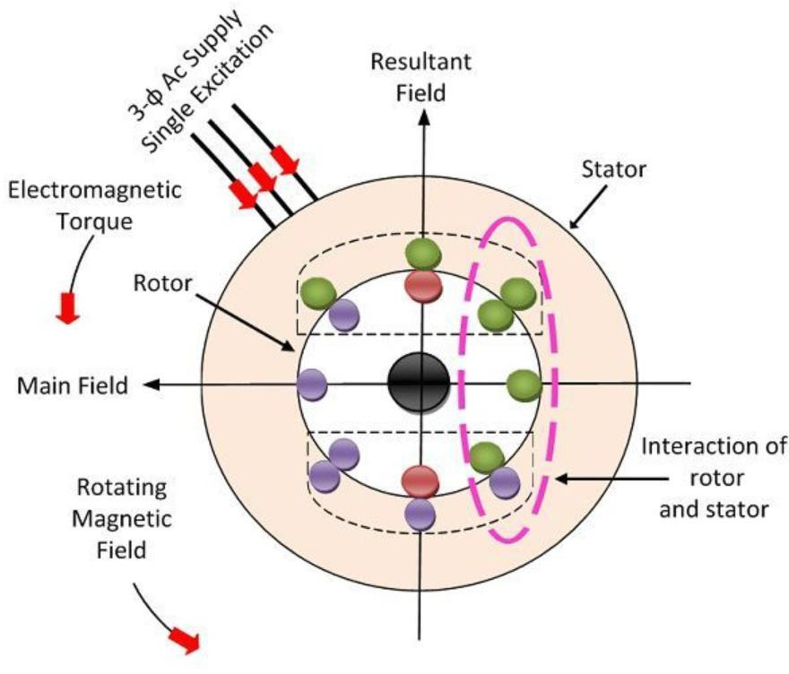

The conductors of the rotor are short-circuited either by the end rings or by the help of the external resistance. The relative motion between the rotating magnetic field and the rotor conductor induces the current in the rotor conductors. As the current flows through the conductor, the flux induces on it. The direction of rotor flux is same as that of the rotor current. Now we have two fluxes one because of the rotor and another because of the stator. These fluxes interact each other. On one end of the conductor the fluxes cancel each other, and on the other end, the density of the flux is very high. Thus, the high- density flux tries to push the conductor of rotor towards the low-density flux region. This phenomenon induces the torque on the conductor, and this torque is known as the electromagnetic torque. The direction of electromagnetic torque and rotating magnetic field is same. Thus, the rotor starts rotating in the same direction as that of the rotating magnetic field. The speed of the rotor is always less than the rotating magnetic field or synchronous speed. The rotor tries to the run at the speed of the rotor, but it always slips away. Thus, the motor never runs at the speed of the rotating magnetic field, and this is the reason because of which the induction motor is also known as the asynchronous motor.

* 1. How will you change the direction of rotation of three phase induction motor?

The direction of rotation of three phase induction motor can be changed by simply interchanging any two phases ,i.e., by connecting R phase

where Y was connected. Which will eventually change the phase sequence of the phases RYB to YRB and the direction will be reversed.

1. What is Slip?

Induction motor rotor always rotate at a speed less than synchronous speed. The difference between the main flux speed (Ns) and their rotor speed (N) is called slip.

It is usually expressed as a percentage of synchronous speed (Ns) and is represented by s

. % slip s = 𝑁𝑠 − 𝑁 𝑁𝑠 𝑋 100 or fractional slip, s = 𝑁𝑠 − 𝑁 𝑁𝑠

Therefore rotor speed N = Ns ( 1 - s ) The difference between synchronous speed and rotor speed is called slip speed i.e., Slip speed = Ns – N

1. List the application of slip ring induction motor?

The Slip ring induction motor possesses a high Starting Torque and low starting current.

It is used mainly for Conveyors, Cranes, Compressors, Elevators, and Hoist etc.

Advantages:

A slip ring induction motor is capable of maintaining the highest torque at any slip. Even a high braking torque can be maintained easily.

It is mainly used for high starting torque which makes use of an external resistance.

They can help in speed control for lifts, railway traction, elevators, etc. High overloading can be done.

Smooth acceleration is easily achievable even under heavy loads. Overheating is avoided during starting.

Disadvantages:

It's more costly to maintain as compared to squirrel cage motor. Less efficient.

Sensitive to voltage fluctuations.

* 1. Why an induction motor is called asynchronous motor?

An induction motor is called asynchronous motor because the actual speed of the motor is not equal to the synchronous speed of the motor. The synchronous

the motor is always more than the actual speed of the motor. If the actual speed of the motor(N) is equal to the synchronous speed (Ns), then no torque will be produced and motoring function not possible.

The synchronous speed is the speed of rotating magnetic field which is produced when the three phase supply is fed to the stator of the motor. The rotor conductors of an induction motor is short circuited at the end rings. The magnetic filed acts on the rotor. When the magnetic field gets linked to the rotor conductor the voltage is induced in the rotor conductor. The underlying principle is electromagnetic induction, similar to transformer.

However, if the [rotating magnetic field](https://www.electricalvolt.com/2019/06/rotating-magnetic-field-in-three-phase-induction-motor/) and rotor rotates at the same synchronous speed, the EMF induced in the rotor is zero because the field will be constant with respect to rotor. The voltage will be induced in the rotor if rate of change of flux exist.

The motor rotation happens when there is [slip](https://www.electricalvolt.com/2019/11/slip-speed-in-an-induction-motor/) between the rotor and the stator. The slip is the difference between the speed of [rotational magnetic field](https://www.electricalvolt.com/2019/06/rotating-magnetic-field-in-three-phase-induction-motor/) and the actual speed of the rotor. The inability of the rotor to catch up the speed of the rotating magnetic field is called the slip of motor. Thus, an induction motor working is possible if [slip](https://www.electricalvolt.com/2019/09/what-is-the-importance-of-slip-in-an-induction-motor/) exist between rotating magnetic field and the actual speed of the rotor. As the load is increased on the motor its slip gets increased.

That is why an induction motor is called asynchronous motor.

* 1. State the effect of rotor resistance on starting torque?

Rotor resistance can be increased upto that when Starting torque becomes equal to Maximum value of torque, because after that Starting torque gets reduced. This value of resistance is called Critical Resistance.

When slip at starting becomes equal to slip corresponding to maximum torque.

Value of Critical Resistance (x) = X’2 – R’2

Thus by adding external resistance to rotor till it becomes equal to, the maximum torque can be achieved at start.

If such a high resistance is kept permanently in the circuit, there will be large copper losses (I2 R) and hence efficiency of the motor will be very poor. Hence such added resistance is cut-off gradually and finally removed from the rotor circuit, in the normal running condition of the motor. So this method is used in practice to achieve higher starting torque hence resistance in rotor is added only at start.

1. What is the crawling of an induction motor?

Squirrel cage type, sometimes exhibit a tendency to run stably at speeds as low as 1/7 the of their synchronous speed, because of the harmonics this phenomenon is known as crawling.

1. What is cogging?

When the number of stator and rotor teeth’s is equal or integral multiple of rotor teeth ,they have a tendency to align themselves exactly to minimum reluctance position. Thus the rotor may refuse to accelerate. This phenomenon is known as cogging.

* 1. How the power factor of an induction motor varies when its load increases?

The input power factor of the induction increases when the mechanical load increases because in general, the higher the resistance (a load), the higher the power factor. A higher power factor means that there is a tapping of electrical energy in terms of active power. And more active power means higher mechanical output to compensate for the increasing rotor resistance. The efficiency of the induction increases when the mechanical load increases because as the motors load increases, its slip increases, and the rotor speed falls. Since the rotor speed is slower, there is more relative motion between the rotor and the stator magnetic fields in the machine. Greater relative motion produces a stronger rotor voltage which in turn produces a

larger rotor current. With a larger rotor current, the rotor magnetic field also increases. The increase in the rotor magnetic field tends to increase the overall torque induced in the motor. Ultimately induction motors are more efficient when they are running closer to synchronous speed i.e. the pullout torque is near synchronous speed.

PART IIIA UNIVERSITY EXAM QUESTION PATTERN – 6 MARK (EACH QUESTION CARRIES 6 MARKS) ANSWER ANY 10 QUESTION

* + 1. Develop the equivalent circuit for 3-phase induction motor?
    2. Explain the different speed control methods of squirrel cage induction motor.

There can be three ways to control the speed of squirrel cage induction motor.

1. Voltage changes
2. Frequency changes
3. Stator poles
4. Voltage changes

First method is by means of changing the input voltage applied for excitation of stator winding. Although it looks simple to change the value of voltage, however very large change in voltage is required to slightly change the speed of the motor and such voltage changes also effects the flux, so this method is used very rarely.

1. Frequency changes

Second method can be changing the frequency of applied voltage signal for excitation. As relation between speed and frequency is given by:

Ns= (120*f)/P

Thus, speed is directly proportional to the frequency of applied voltage for excitation of stator. However, this method has very limited range and cannot be used for large range of speed changes.

1. Stator poles

From relation Ns= (120*f)/P, it is clear that speed of stator Ns is inversely proportional to the number of poles of winding. So increasing number of poles will reduce the speed of motor. While decreasing poles will results in increasing speed.

Thus, number of poles can be increased from two to any number in order to decrease the speed of motor. For this purpose, multiple windings can be used each having different number of poles. Then selection between them is made, according to speed requirements.

3. Describe the principle of operation of synchronous induction motor.

A synchronous motor works on the principle of magnetic attraction between two magnetic fields of opposite polarity; one is the rotating magnetic field of the stator and the other is the magnetic field of the rotor.

A synchronous motor has torque only at synchronous speed, so special steps have to be taken to get the motor up to speed and synchronized with the supply. The two magnetic fields are then rotating at the same speed and lock in with each other.

Effect of Load on a Synchronous Motor

When a synchronous motor runs on no load, the relative positions of stator and rotor poles coincide.

When a load is applied, the rotor must still continue to rotate at synchronous speed but owing to the retarding action of the load, the rotor pole lags behind the stator pole. Their relative positions are displaced by the angle a which is called the ‘torque’ or ‘load’ angle. The greater the load applied, the greater the torque angle.

The magnetic coupling between each stator and rotor pole distorts according to the load applied. If the load on the motor becomes excessive, the magnetic coupling breaks and the rotor slows down until it stops.

When the motor is rotating at synchronous speed, with a fixed DC excitation in the rotor windings, the rotor flux cuts the stator windings, inducing a voltage in each phase winding. By Lenz’s law, this voltage opposes the applied voltage. The phase relationship between this induced voltage and the applied voltage depends on the relative positions of each stator and rotor pole, which in turn depend on the load applied to the motor.

Using the example of an ideal synchronous motor with no losses, we can examine the operation on no load. Neglecting motor losses, on no load the

The resultant voltage *V*R across the windings is zero, and so the current drawn from the supply is also zero.

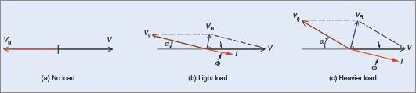

Effect of load on the line current with constant excitation

When a light load is applied to the motor, the torque angle α increases, and the induced voltage *V*g in the stator windings is now (180 − α) °E out of phase with the applied voltage *V* .

These two voltages combine to produce an effective voltage *V*R across the stator windings, which is sufficient to draw a current *I* from the supply. Because of the relatively high inductance of the stator windings, the line current *I* in each winding lags each resultant voltage *V*R by nearly 90°E. This causes the line current *I* to lag the applied voltage by Φ.

As the load is increased, so the torque angle is increased. This causes an increase in the resultant voltage *V*R across each stator winding . Because of the increase in the value of *V*R, the line current *I* increases and the phase angle Φ between the applied voltage *V* and the line current *I* also increases. Therefore, for fixed excitation, any increase in the load on a synchronous motor will cause an increase in the line current, at a lower power factor.

Effect of Varying Field Excitation

If the load applied to a synchronous motor is constant, the power input to the motor is also constant. When the rotor field excitation is varied, the induced voltage in each stator winding is also altered.

The phasor diagram in overleaf represents the conditions for a given load at unity power factor. The power input per phase is *VI*1. If the rotor field excitation is decreased, the induced voltage *V*g decreases .This causes the line current *I*2 to lag the applied voltage *V* by Φ2.

Since the load, and so the power input, is constant, the power component of *I*2 must remain the same as *I*1 in figure. The line current *I*2 must increase to accommodate

the lagging power factor. Therefore, a reduction in the DC field excitation causes an increase in line current and a lagging power factor.

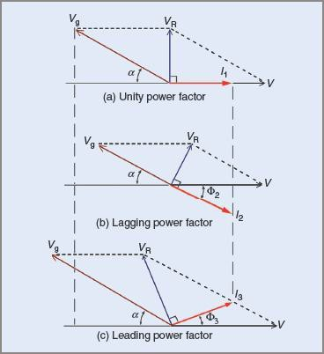

Figure Effect of varying the DC excitation

If the DC excitation is increased, the induced voltage *V*g increases. The line current *I*3 will therefore lead the applied voltage *V* by Φ3, and will also be greater than *I*1 in Figure because the power component is the same, owing to the load remaining constant. Therefore, an increase in DC excitation causes an increase in line current, and a leading power factor.

It can be seen that if the excitation of a synchronous motor on a constant load is varied from a low to a higher value then:

1. The Stator Current Gradually Decreases, Reaches A Minimum, And Then Increases Again
2. The Power Factor, At First Lagging, Gradually Increases, Becomes Unity When The Stator Current Is A Minimum, And Then Decreases Again But Becomes Leading.

Care should be taken when adjusting the excitation of a synchronous motor. There are limits to which it can be taken with safety.

1. Explain any one method of speed control of three- phase induction motor.
2. Draw the slip-torque characteristics for a three-phase induction motor and explain.
3. Explain how a rotating magnetic field is produced in a three-phase induction motor.
4. Draw and explain the equivalent circuit of a three-phase induction motor.
5. Describe with a neat diagram, the principle of operation of induction generator.
6. Draw and explain the torque/slip curves of a three-phase induction motor for different values of rotor resistance.
7. starting from the first principles, develop the equivalent circuit of a 3- phase induction motor.
8. Explain the procedure of drawing the circle diagram of an induction motor. How are the performance character tics obtained from it?
9. Explain the operation of induction generator

PART IV UNIVERSITY EXAM QUESTION PATTERN – 6 MARK (EACH QUESTION CARRIES 2 MARKS) ANSWER ALL QUESTION

1. What is the function of starter?

A starter is an electrical device which controls the electrical power for starting a motor. These electrical devices are also used for the purpose of stopping, reversing and protecting electric motors. The following are the two major components of a starter:

* 1. Contactor: The main function of the contactor is to control the electric current to the motor. A contactor can make or break power to the circuit.
  2. Overload Relay: Overheating and drawing too much current can cause the motor to burn out and become practically useless. [Overload relays](https://www.c3controls.com/showcase/overload-relays/) prevent this from happening and protect the motor from any potential danger.

A starter is an assembly of these two components, which allows it to turn on or off an electric motor or motor controlled electrical equipment. The starter also provides the necessary overload protection to the circuit.

The following are the most fundamental functions that a starter has to perform:

1. Control: The control function is mainly carried out by the contactor

electrical circuit. The switching is done by the main contacts (poles) of the contactor. An electromagnetic coil is energized, which open or close the contacts. This electromagnetic coil has a nominal control voltage, and can either be an AC or DC voltage.

1. Short-Circuit Protection: In industrial applications, normal load current can be up to thousands of amperes. In the case of a short-circuit fault, the fault current can go over 100,000 amperes. This can cause severe damage to the equipment. The short-circuit protection disconnects the supply and prevents the potential damage in a safe manner. Short circuit protection is provided by [fuses or circuit breakers](https://www.c3controls.com/showcase/motor-protection-circuit-breakers/) in a Combination Motor Controller.
2. Overload Protection: When a motor draws more current than it is designed to, an overload condition is caused. The main objective of an overload relay is to detect the excess currents. When an overload is detected, the auxiliary contact of the overload relay opens the circuit and prevents the motor from burning out or overheating. Electronic or electromechanical overload relays are used in combination with a contactor to provide the required overload protection.
3. Disconnecting and Breaking: In order to prevent an unintended restart, it is required to disconnect the motor from the main power circuit. In order to safely perform maintenance on a motor or starter, a motor must be able to switch off and be isolated from the power. The disconnect switch of the circuit provides this function. Disconnecting and breaking is provided by a disconnect switch or circuit breaker in a Combination Motor Controller (or can be installed remotely from the starter).
4. List the disadvantages of autotransformer starter.

The main disadvantages of autotransformer starter are listed below.

* + One of its great disadvantages is the limitation of its operation frequency. It is always necessary to know the operation frequency in order to determine a suitably rated auto-transformer.
  + The compensating switch is much more expensive than a Star-Delta starter due to the auto-transformer.
  + Due to the size of the auto-transformer starter, much larger control panels
  + The circuit is complex and involves a relatively expensive autotransformer
  + Due to the size of the autotransformer starter, a much larger control, the panel is required which increases the price.
  + If space is limited, it might not be possible to connect the korndorfer starter to an existing machine due to its physical size.
  + One of its major drawbacks is the frequency constraint of its operation. It is always necessary to know the operation frequency in order to select an autotransformer that is appropriately rated.

1. What are the advantages of DOL starter?

The advantages of a DOL starter include:

* + Simple and most economical starter.
  + More comfortable to design, operate and control.
  + Provides nearly full starting torque at starting.
  + Easy to understand and troubleshoot.
  + DOL starter connects the supply to the delta winding of the motor.
  + DOL starter connects the supply to the delta winding of the motor device
  + Provides nearly full starting torque at starting
  + DOI is an inexpensive starter

1. Name the different methods of electric braking. types of Electric Braking:

There are three types of electric braking, all of which are applicable to the usual types of electric motors, viz. plugging (or counter-current braking), dynamic (or rheostatic) braking and regenerative braking.

1. Plugging or Counter-Current Braking:
2. This is the simplest type of braking. Plugging or counter-current braking occurs when the motor windings are connected for reverse direction of

rotation at a time when the armature is still rotating in the forward direction either under the action of an external torque or due to inertia. Plugging involves reconnection of power supply to the motor so that it tends to drive in the opposite direction. It is obvious that, left to itself, the system will come to rest and then accelerate in the reverse direction. In case, it is required to bring the drive system to rest, it is necessary to include a special device to cut off the supply exactly at the instant when the motor stops.

1. During the braking period, the energy is drawn from the supply. The energy drawn from the supply and stored or kinetic energy of the rotating parts of motor and its driven machines are dissipated in the series current limiting resistor. Thus this method is wasteful of energy. Other drawbacks of this method of electric braking are the shock caused to the motor and equipment and heavy inrush of current at the time of braking.
2. This method provides greater braking torque than that provided by rheostatic (or dynamic) braking. This method is used to get either a quick reversal or to get a rapid stop. This method is commonly used in controlling rolling mills, elevators, printing presses, machine tools etc.
3. This method can be applied to direct current, alternating current induction and synchronous motors.
4. 2. Dynamic (or Rheostatic) Braking:
5. In this method of braking the motor is disconnected from the supply and operated as a generator driven by the kinetic energy of the rotating parts of the motor and its driven machines. Thus the kinetic energy of rotation is converted into electrical energy, which is dissipated in the external resistance connected across the motor at the braking instant. By this method, energy required from the supply to brake the motor, has been eliminated as compared to the previous method (plugging) and this is marked advantage. This method of braking can be applied to brake the direct current motors, synchronous motors, and induction motors (with a separate source of dc excitation during braking).

10.3. Regenerative Braking:

1. In the previous two methods of electric braking namely plugging and rheostatic braking stored energy of the rotating parts of the motor and its driven machine is wasted whilst in plugging extra energy is drawn during the braking period and is wasted. In regenerative braking, mechanical energy is converted into electrical energy, part of which is returned to

the rest of the energy is lost as heat in the windings and the bearings of the electrical machines. Regeneration does not, in general, involve any switching operation, unless it is required to change the speed at which it becomes effective. Most of the electrical machines pass smoothly from motoring to generating operation, when overdriven by load.

1. For regenerative braking it is necessary for:

13.(i) Supply voltage to drop,

14.(ii) The motor to be overexcited or

15.(iii) The motor to be running at a speed higher than no-load speed.

16.In all of these cases the armature current is reversed and a retarding torque is produced, slowing down the motor until the back emf of the armature becomes equal to the supply voltage. Regenerative braking will not stop the motor. It is effective only for braking hauling loads. They may occur in a crane motor due to action of the lowering load or in the motor of an electric locomotive moving down grade.

1. What are the advantages of dynamic braking of an induction motor?

The advantages of dynamic braking include ease of speed regulation of three-phase induction motors and mechanical losses can be reduced. A system for reversing the direction of star-delta three phase induction motor rotation with Programmable Logic Control (PLC) as a controller.

1. What is the disadvantage of dynamic braking of an induction motor? The disadvantages are
   * This is a much-used method where en electric motor is worked as a generator once it is detached from the power source
   * In this braking, the energy which is stored will dissipate through the resistance of braking & other components used in the circuit.
   * This will reduce braking [components](https://www.elprocus.com/basic-components-used-electronics-electrical/) based on wear on friction & regeneration reduces the usage of net energy.
2. What is eddy current loss?

When an alternating magnetic field is applied to a magnetic material, an emf is induced in the material itself according to Faraday’s Law of Electromagnetic induction. Since the magnetic material is a conducting material, these EMFs circulate current within the body of the material.

These circulating currents are called Eddy Currents. They will occur when the conductor experiences a changing magnetic field.

As these currents are not responsible for doing any useful work, and it produces a loss (I2R loss) in the magnetic material known as an Eddy Current Loss. Similar to hysteresis loss, eddy current loss also increases the temperature of the magnetic material.

The eddy current power loss in a magnetic material is given by the equation shown below:



where,

Ke – co-efficient of eddy current. Its value depends upon the nature of magnetic material

Bm – maximum value of flux density in wb/m2 T – thickness of lamination in meters F – frequency of reversal of the magnetic field in Hz V – volume of magnetic material in m3

1. How does the slip vary with load?

With an increase in load on the motor, the rotor current increase. The torque also gets increased with increase in the rotor current. The operating point of the speed torque curve of the load shift at the new value of the motor’s speed-torque curve. The slip gets increased with an increase in loading on the motor.

Slip increases with increasing load - providing a greater torque.

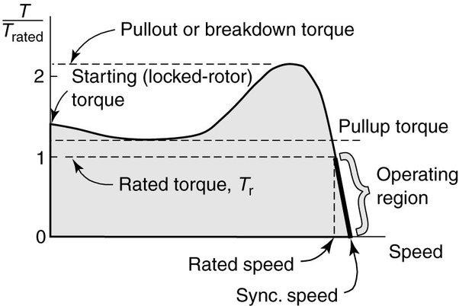

1. Is it possible to start 3 phase slip ring induction motor on load?

As these motors have considerably high starting torque with low starting current, these motors can be started on load. The external resistance is used only for the starting purpose, after which the motor gradually picks up the speed, the resistance gradually cut-off. These rings are isolated after the motor reaches its rated speed. The carbon brushes are lifted and the rings are short circuited thus making them very similar to squirrel cage motors.

1. What do you mean by negative slip?

An AC induction motor consists of two assemblies, namely a stator and a rotor. The working of this machine is due to interaction of currents flowing in the rotor bars and the rotating magnetic field in the stator windings ( A torque is produced due to the same).

The difference between synchronous speed of the rotating magnetic field and the shaft( rotor) rotating speed is called slip.

Slip= (Ns-Nr) /Ns

From the above equation it is clear that, for slip to be negative, the rotor speed should be greater than synchronous speed. Hence, Negative slip is a situation when an induction motor becomes an induction generator.

PART V UNIVERSITY EXAM QUESTION PATTERN – 6 MARK (EACH QUESTION CARRIES 2 MARKS) ANSWER ALL QUESTION

* 1. Name the application of AC series motor.

This motor is a kind of motor which construction is done to work on both DC and Ac single-phase supply. The working principle is the same as the dc series motor and has advantages of the dc series motor like high torque.

The DC motor which runs on alternating supply called an Ac series motor. However, some changes must be made in the DC series motor that is to operate satisfactorily on alternating supply.

AC series motors are mainly used in the following:

* + High-speed vacuum cleaner
  + Sewing machines
  + Used in drills and power tools
  + Electric shavers
  1. What is stepper motor?

A stepper motor, also known as step motor or stepping motor, is a [brushless DC](https://en.wikipedia.org/wiki/Brushless_DC_electric_motor) [electric motor](https://en.wikipedia.org/wiki/Brushless_DC_electric_motor) that divides a full rotation into a number of equal steps. The motor's position can be commanded to move and hold at one of these steps without any [position sensor](https://en.wikipedia.org/wiki/Rotary_encoder) for [feedback](https://en.wikipedia.org/wiki/Feedback) (an [open-loop controller](https://en.wikipedia.org/wiki/Open-loop_controller)), as long as the motor is correctly sized to the application in respect to [torque](https://en.wikipedia.org/wiki/Torque) and speed.

There are three main types of stepper motors:[[1]](https://en.wikipedia.org/wiki/Stepper_motor#cite_note-R000534-1)

1.[Permanent magnet stepper](https://en.wikipedia.org/w/index.php?title=Permanent_magnet_stepper&action=edit&redlink=1) 2.[Variable reluctance stepper](https://en.wikipedia.org/wiki/Reluctance_motor) 3.[Hybrid synchronous stepper](https://en.wikipedia.org/w/index.php?title=Hybrid_synchronous_stepper&action=edit&redlink=1)

[Permanent magnet motors](https://en.wikipedia.org/wiki/Permanent_magnet_motor) use a [permanent magnet](https://en.wikipedia.org/wiki/Permanent_magnet) (PM) in the rotor and operate on the attraction or repulsion between the rotor PM and the [stator](https://en.wikipedia.org/wiki/Stator) electromagnets.

Pulses move the rotor in discrete steps, CW or CCW. If left powered at a final step a strong [detent](https://en.wikipedia.org/wiki/Detent) remains at that shaft location. This detent has a predictable spring rate and specified torque limit; slippage occurs if the limit is exceeded. If current is removed a lesser [detent](https://en.wikipedia.org/wiki/Detent) still remains, therefore holding shaft position

or other torque influences. Stepping can then be resumed while reliably being synchronized with control electronics.

[Variable reluctance](https://en.wikipedia.org/w/index.php?title=Variable_reluctance&action=edit&redlink=1) (VR) motors have a plain [iron](https://en.wikipedia.org/wiki/Iron) rotor and operate based on the principle that minimum [reluctance](https://en.wikipedia.org/wiki/Magnetic_reluctance) occurs with minimum gap, hence the rotor points are attracted toward the stator [magnet poles](https://en.wikipedia.org/wiki/Magnet). Whereas hybrid synchronous are a combination of the permanent magnet and variable reluctance types, to maximize power in a small size.[[2]](https://en.wikipedia.org/wiki/Stepper_motor#cite_note-2)

VR motors have power on detents but do not have power off detents.

Stepper motors are used in [floppy disk drives](https://en.wikipedia.org/wiki/Floppy_disk), [flatbed scanners](https://en.wikipedia.org/wiki/Image_scanner), [computer](https://en.wikipedia.org/wiki/Computer_printer) [printers](https://en.wikipedia.org/wiki/Computer_printer), [plotters](https://en.wikipedia.org/wiki/Plotter), [slot machines](https://en.wikipedia.org/wiki/Slot_machine), [image scanners](https://en.wikipedia.org/wiki/Image_scanner), [compact disc](https://en.wikipedia.org/wiki/Compact_disc) drives, [intelligent](https://en.wikipedia.org/wiki/Intelligent_lighting) [lighting](https://en.wikipedia.org/wiki/Intelligent_lighting), [camera lenses](https://en.wikipedia.org/wiki/Camera_lens), [CNC machines](https://en.wikipedia.org/wiki/Numerical_control), and [3D printers](https://en.wikipedia.org/wiki/3D_printer).

1. What is the function of capacitor in a single phase induction motor?

A single phase induction motor cannot produce a rotating torque.So in order to start the motor by increasing the starting torque capacitor is used. Answer: Starting torque in single phase induction motor is 0. A capacitor is used to develop starting torque by creating a phase shift between the currents.

1. What kind of motor is used in a mixie?

For a mixer grinder, we use universal motor. This motor is used in other home appliances too like refrigerators, fans, etc. The universal motor is an electric motor that can operate on either AC or DC power and uses an electromagnet as its stator to create the magnetic field. It has been characterized to have higher power output with the smaller size and starting torque to be high at a lower speed and can carry high loads.

It is a commutated series-wound motor where the [stator](https://en.wikipedia.org/wiki/Stator)'s [field coils](https://en.wikipedia.org/wiki/Field_coil) are connected in series with the rotor windings through a [commutator](https://en.wikipedia.org/wiki/Commutator_(electric)). It is often referred to as an AC series motor. The universal motor is very similar to a DC series motor in construction, but is modified slightly to allow the motor to operate properly on AC power. This type of electric motor can operate well on AC because the current in both the field coils and the [armature](https://en.wikipedia.org/wiki/Armature_(electrical_engineering)) (and the resultant magnetic fields) will alternate (reverse polarity) synchronously with the supply. Hence the resulting mechanical force will occur in a consistent direction of rotation, independent of the direction of applied voltage, but determined by the commutator and polarity of the field coils.

Universal motors have high starting [torque](https://en.wikipedia.org/wiki/Torque), can run at high speed, and are lightweight and compact. They are commonly used in portable power

easy to control, electromechanically using tapped coils, or electronically. However, the commutator has [brushes](https://en.wikipedia.org/wiki/Brush_(electric)) that wear, so they are much less often used for equipment that is in continuous use. In addition, partly because of the commutator, universal motors are typically very noisy, both acoustically and electromagnetically.

1. In which direction does a shaded pole induction motor run?

A shaded-pole motor is a small [squirrel-cage motor](https://en.wikipedia.org/wiki/Squirrel-cage_motor) in which the auxiliary [winding](https://en.wikipedia.org/wiki/Electromagnetic_coil) is composed of a copper ring or bar surrounding a portion of each pole. When single phase AC supply is applied to the stator winding, due to shading provided to the poles, a rotating magnetic field is generated. This auxiliary single- turn winding is called a [shading coil](https://en.wikipedia.org/wiki/Shading_coil). Currents induced in this coil by the magnetic field create a second electrical phase by delaying the [phase](https://en.wikipedia.org/wiki/Phase_(waves)) of [magnetic flux](https://en.wikipedia.org/wiki/Magnetic_flux) change for that pole (a *shaded pole*) enough to provide a 2-phase [rotating magnetic field](https://en.wikipedia.org/wiki/Rotating_magnetic_field). The direction of rotation is from the unshaded side to the shaded (ring) side of the pole. Since the phase angle between the shaded and unshaded sections is small, shaded-pole motors produce only a small starting [torque](https://en.wikipedia.org/wiki/Torque) relative to torque at full speed.

1. Why singe phase induction motor has low power factor?

The less than unity power factor is due to magnetizing current required by the stator. This fixed current is a larger proportion of total motor current as the motor load is decreased. At light load, the full magnetizing current is not required. It could be reduced by decreasing the applied voltage, improving the power factor and efficiency.

1. What do you mean by split phase motor?

A split-phase induction motor is a type of single-phase induction motor in which the stator is provided with a starting or auxiliary winding (S) and a main or running winding (M). The starting winding is displaced by 90° from the main winding as shown in the figure.

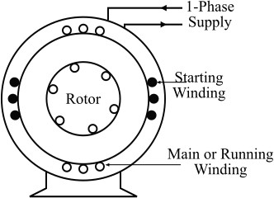

The starting winding operates only during the brief period when the motor starts up. The starting and the main windings are so designed that the starting winding (S) has a high resistance and relatively low reactance while the main winding (M) has relatively low resistance and high reactance so that the currents flowing in the two windings have reasonable phase difference (α) of about 25° to 30° as shown in the phasor diagram.

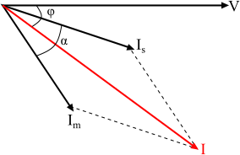

Operation of Split-Phase Induction Motor

When the starting winding of the motor is connected to the source of single-phase AC supply, the starting winding carries a current *Is* while the main winding carries a current *Im* as shown in the connection diagram.

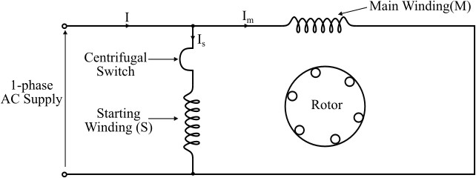

As the starting winding is made highly resistive whereas the main winding highly inductive. Therefore, the currents *Is* and *Im* in the two windings have a reasonable phase difference of about 25° to 30° between them. As a result, a weak revolving field is produced which starts the motor. The starting torque of the split-phase motor is given by,

1. τst=kIsImsinατ𝑠𝑡=𝑘𝐼𝑠𝐼msin𝛼

Where, *k* is a constant of proportionality whose value depends upon the design of the machine.

When the motor speed reaches about 80% of the synchronous speed, then the centrifugal switch isolates the starting winding from the circuit. Now, the motor operates as a single-phase induction motor and continues to accelerate till it reaches the normal speed. The normal speed of the motor is less than the synchronous speed and it depends upon the mechanical load on the shaft of the motor.

1. How will you change the direction of rotation of a repulsion motor?

A repulsion motor is a type of [electric motor](https://en.wikipedia.org/wiki/Electric_motor) which runs on [alternating current](https://en.wikipedia.org/wiki/Alternating_current) (AC). It was formerly used as a [traction motor](https://en.wikipedia.org/wiki/Traction_motor) for electric trains (e.g. [SR Class CP](https://en.wikipedia.org/wiki/SR_Class_CP) and [SR](https://en.wikipedia.org/wiki/SR_Class_SL) [Class SL](https://en.wikipedia.org/wiki/SR_Class_SL) [electric multiple units](https://en.wikipedia.org/wiki/Electric_multiple_unit)) but has been superseded by other types of motors. Repulsion motors are classified as [single phase](https://en.wikipedia.org/wiki/Single-phase_electric_power) motors.

In repulsion motors the [stator](https://en.wikipedia.org/wiki/Stator) windings are connected directly to the AC [power](https://en.wikipedia.org/wiki/Electric_power_system) [supply](https://en.wikipedia.org/wiki/Electric_power_system) and the [rotor](https://en.wikipedia.org/wiki/Rotor_(electric)) is connected to a [commutator](https://en.wikipedia.org/wiki/Commutator_(electric)) and [brush](https://en.wikipedia.org/wiki/Brush_(electric)) assembly, similar to that of a [direct current](https://en.wikipedia.org/wiki/Direct_current) (DC) motor.

The direction of rotation is determined by the position of the brushes with respect to the magnetic field of the stator. If the brushes are shifted clockwise from the main magnetic axis, the motor will rotate in a clockwise direction. If the brushes are shifted counter-clockwise from the main magnetic axis, the motor will rotate in a counter-clockwise direction.

* 1. What happens when the centrifugal switch fails to close?

A centrifugal switch is an electrical switch powered by the centrifugal force created by a rotating shaft. This centrifugal force is typically provided by a gasoline engine or [electric motor](https://www.electrical4u.com/electrical-motor-types-classification-and-history-of-motor/). Centrifugal switches are designed to activate or deactivate the rotational speed of the shaft.

If the start switch does not open when it is needed, the start winding will overheat and flame out, and the engine will not start next time. If the centrifugal start switch is not closed, the engine will overheat the main winding without any main winding failure. The centrifugal switch should be disconnected at about 70 to 80 per cent of the full speed of the engine. If it is not disconnected, a heavy current will continue to flow through the starting winding of the engine, which eventually results in the failure of the starting winding and engine. Also, the speed and the current cannot reach its maximum.

* 1. Name the different classification of stepper motor?

A stepper motor, also known as step motor or stepping motor, is a [brushless DC](https://en.wikipedia.org/wiki/Brushless_DC_electric_motor) [electric motor](https://en.wikipedia.org/wiki/Brushless_DC_electric_motor) that divides a full rotation into a number of equal steps. The motor's position can be commanded to move and hold at one of these steps without any [position sensor](https://en.wikipedia.org/wiki/Rotary_encoder) for [feedback](https://en.wikipedia.org/wiki/Feedback) (an [open-loop controller](https://en.wikipedia.org/wiki/Open-loop_controller)), as long as the motor is correctly sized to the application in respect to [torque](https://en.wikipedia.org/wiki/Torque) and speed.

There are three main types of stepper motors:[[1]](https://en.wikipedia.org/wiki/Stepper_motor#cite_note-R000534-1)

* + 1. [Permanent magnet stepper](https://en.wikipedia.org/w/index.php?title=Permanent_magnet_stepper&action=edit&redlink=1)
    2. [Variable reluctance stepper](https://en.wikipedia.org/wiki/Reluctance_motor)
    3. [Hybrid synchronous stepper](https://en.wikipedia.org/w/index.php?title=Hybrid_synchronous_stepper&action=edit&redlink=1)

[Permanent magnet motors](https://en.wikipedia.org/wiki/Permanent_magnet_motor) use a [permanent magnet](https://en.wikipedia.org/wiki/Permanent_magnet) (PM) in the rotor and operate on the attraction or repulsion between the rotor PM and the [stator](https://en.wikipedia.org/wiki/Stator) electromagnets.

Pulses move the rotor in discrete steps, CW or CCW. If left powered at a final step a strong [detent](https://en.wikipedia.org/wiki/Detent) remains at that shaft location. This detent has a

rate and specified torque limit; slippage occurs if the limit is exceeded. If current is removed a lesser [detent](https://en.wikipedia.org/wiki/Detent) still remains, therefore holding shaft position against spring or other torque influences. Stepping can then be resumed while reliably being synchronized with control electronics.

[Variable reluctance](https://en.wikipedia.org/w/index.php?title=Variable_reluctance&action=edit&redlink=1) (VR) motors have a plain [iron](https://en.wikipedia.org/wiki/Iron) rotor and operate based on the principle that minimum [reluctance](https://en.wikipedia.org/wiki/Magnetic_reluctance) occurs with minimum gap, hence the rotor points are attracted toward the stator [magnet poles](https://en.wikipedia.org/wiki/Magnet). Whereas hybrid synchronous are a combination of the permanent magnet and variable reluctance types, to maximize power in a small size.[[2]](https://en.wikipedia.org/wiki/Stepper_motor#cite_note-2)

VR motors have power on detents but do not have power off detents.

PART VA UNIVERSITY EXAM QUESTION PATTERN – 6 MARK (EACH QUESTION CARRIES 6 MARKS) ANSWER ANY 5 QUESTION

1. Give the classification of single phase motors .Explain any two types of single phase induction motors.
2. Explain the double field revolving theory for operation of single phase induction motor.

The double field revolving theory of single phase induction motor is proposed to explain this problem of no torque developed at starting and yet torque once rotated. Double revolving field theory is based on the fact that an alternating sinusoidal flux can be expressed by two revolving fluxes and each flux equal to one half of the maximum value of alternating flux Φm. i.e Φm/2 and each flux rotating at synchronous speed Ns = 120f/p, in the opposite direction of each other.

The instantaneous value of flux due to the stator current of single phase induction motor is,

Φ=Φm cosωt

Let, two rotating magnetic fluxes Φ1 and Φ2, each flux having the magnitude of Φm/2 and rotating in the opposite direction with angular velocity ω.

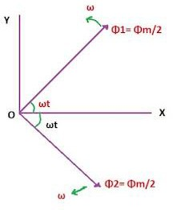

Consider the two fluxes start revolving from OX axis at a time t=0, after some time t second the angle through which flux vector have rotated is at

Resolving the flux vector along x-axis and y-axis we get X component=Φm/2* cosωt + Φm/2* cosωt =Φm cosωt Y component=Φm/2 *sinωt - Φm/2 * sinωt =0

Hence resultant flux



This resultant flux vector Φ=Φm cosωt along x-axis therefore as shown in figure alternating field can be replaced by two relating fields of half in amplitude and revolving in the opposite direction to each other at synchronous [speed](https://www.electricportal.info/2019/06/speed-control-of-three-phase-induction-motor.html). here we can see that the resultant vector of two revolving flux is a stationary vector that oscillates in length with time along the x-axis.

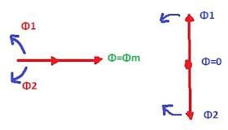

When the rotating flux vector is in phase as shown in the diagram the resultant vector is Φ=Φm, When out of phase by 180 degrees the resultant vector is Φ=0.

1. Explain the operation of shaded pole induction motor with diagram.

The construction of a shaded type induction motor is similar to a normal [single-](https://www.electricaldeck.com/2020/01/types-of-single-phase-induction-motors.html) [phase induction motor](https://www.electricaldeck.com/2020/01/types-of-single-phase-induction-motors.html), except for its stator pole. The stator poles of a shaded pole motor are divided into two parts. One part of the poles consists of a short-circuited coil made up of copper which is known as the shading coil ( shaded part ) and the remaining part is known as the unshaded part of the pole, hence the motor is known as a shaded pole induction motor.

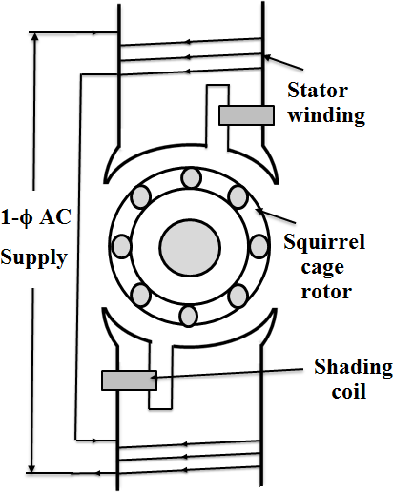

The construction of the rotor is of normal squirrel cage type of a 3-phase induction motor. The below figure shows the single-phase two-pole induction motor with a shading coil on both the stator poles.

Working Principle

When a single-phase a.c. supply is given to the stator winding. The poles of the motor generate a magnetic field φm, but there are one more magnetic field φs produced by shading coils either in the same or opposite direction. The combination of this both fields makes a rotating magnetic field which makes the rotor to rotate. Let us consider three different cases at different time instants t1, t2, and t3 on a positive half cycle of an a.c. supply.

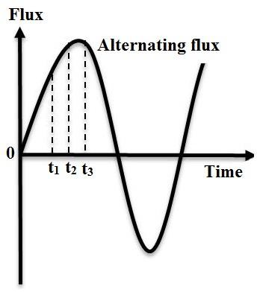

Case - 1 ( At instant t = t1 ) :

As seen from the waveform, at instant t = t1. The current in the coil increases, which in turn increases the flux φm produced by the coil. Now due to supply is alternating, the rate of change of flux will tends to cause an emf induced in a shading coil of that pole. As the shading coil is short-circuited, currents will flow through it. Simultaneously causes to produces another flux φs by the shading coil, which in the opposite direction to the main flux as shown below.

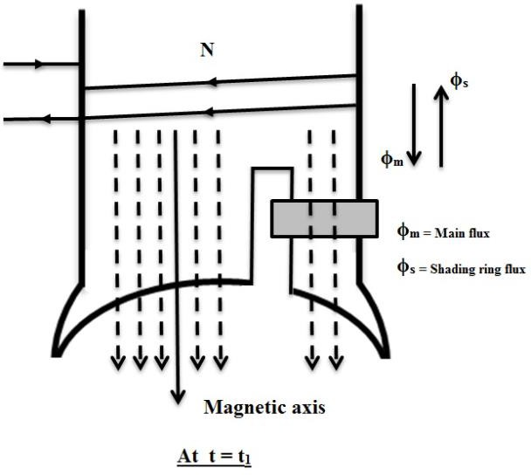

Now due to the opposition of these two fluxes produced by the shading coil and main winding. The net flux across the area of the shading coil will be zero. Therefore, the magnetic axis of the net flux will be at the center of the unshaded part.

Case - 2 ( At instant t = t2 ) :

Now, at instant t = t2 i.e., the maximum or peak value of the cycle or current. Here further there will be no increase in the current ( no change of current ). So it decreases the rate of change of flux, which also decreases the emf induced in the shading coil. At this point, the flux φs produced by the shading coil will be almost negligible. Hence the flux φm produced by the main winding will be uniformly distributed along the pole. Therefore, the magnetic axis of the pole will be at the center of the whole pole ( with shaded and unshaded part ) as shown below.

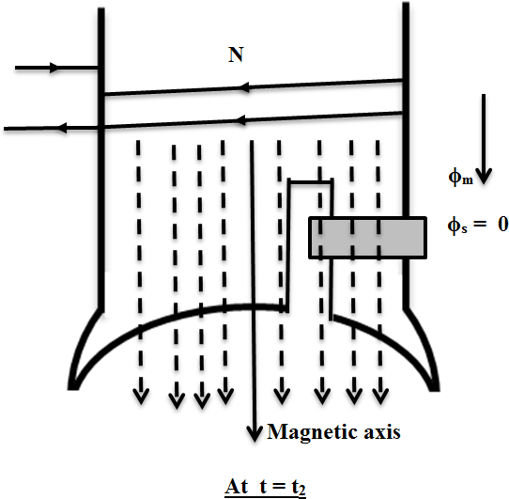

Case - 3 ( At instant t = t3 ) :

At this instant, the rate of change of current will be in decreasing. As the current changes, there will be an induced emf in the shading coil due to the change of flux. But here the direction of the fluxes φm and φs produced by both the main winding and shading coil will be in the same direction. But there will be crowding of flux in the shaded part as compared to the unshaded part. Due to this, the net magnetic axis of the pole will be at the center of the shading part of that pole, as shown below.

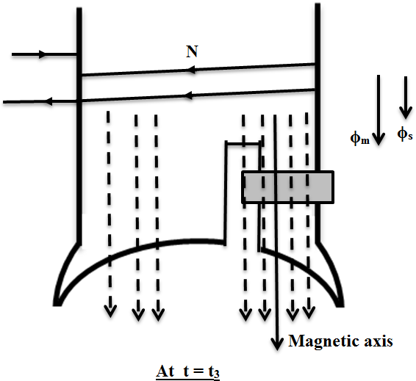

This sequence of instants keeps on repeating for the negative half cycle also. As it will result in the production of a rotating magnetic field. By which the motor tends to start on its own. The [starting torque](https://www.electricaldeck.com/2020/03/torque-equation-of-induction-motor.html) produced by this type of motor will be 50% to 60% of the full-load torque.

Advantages of Shaded Pole Induction Motor :

* 1. Simple in construction.
  2. Cheap.
  3. Extremely rugged and
  4. No centrifugal switch is required.

Disadvantages of Shaded Pole Induction Motor :

1. Starting torque is poor.
2. [Efficiency](https://www.electricaldeck.com/2020/04/efficiency-and-power-flow-diagram-of-induction-motor.html) is very low due to [copper losses](https://www.electricaldeck.com/2020/01/losses-in-induction-motor.html) in the shading ring and
3. Very limited over-load capacity.

Speed Reversal :

The speed reversal is very difficult. To reverse the direction of rotation. two sets of shading rings are to be provided on both portions of the poles. By opening any ring and closing the other ring particular direction of rotation can be achieved. But the method is complicated and expensive.

Applications of Shaded Pole Induction Motor :

These are used in small fans, toys, hair, dryers film projectors. advertising displays etc., where starting torque required is very low.

1. Develop equivalent circuit of a single phase induction motor ignoring core losses.
2. Explain the working principle of single phase induction motor .Mention its four applications.
3. What is the principle and working of hysteresis motor? Explain briefly.

A hysteresis motor works on the principle of hysteresis losses (it is a loss occurred due to magnetization and demagnetization of the material depending on the direction of flow of current). It can be operated either using a single phase or three phases and in a noiseless operating environment, it maintains a constant speed. The torque generated in the motor is due to the hysteresis and eddy current which is induced due to stator winding. There are 4 types of hysteresis motor they are

* Cylindrical type
* Disk type
* Circumferential-Field type
* Axial-Field type Construction

The main parts of hysteresis motor are stator and rotor, the stator is similar to single- phase or three-phase (using three phases balanced winding) motor. Where [single-](https://www.elprocus.com/induction-motor-types-advantages/) [phase motor](https://www.elprocus.com/induction-motor-types-advantages/) is classified into two types shaded pole type and permanent split capacity type.

* The advantage of shaded pole type motor is that it occupies less area and it requires less cost, but the disadvantage is that the torque generated is not uniform causing noisy operation.
* By using a split capacitive type rotor a balance two-phase supply is provided, which generates uniform torque with noiseless operation. But the disadvantage of this is that it occupies more area and the cost is high.

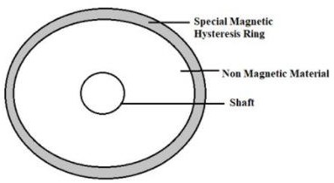

The rotor is made up of hysteresis material, containing a number of hysteresis rings (made up of hard chrome or cobalt or steel) which has a very large hysteresis loop. It is used to reduce the eddy current losses. Since it has a larger weight to overcome this disadvantage we use a non-magnetic material (also known as a spider) made up of aluminum, which is present at the center portion of the motor. The main advantage of this non-magnetic material is that it lightens the rotor weight, by improving the speed of the motor and reduces the value of inertia.

Working Principle of Hysteresis Motor

Hysteresis motor starts like a single-phase induction motor and runs like a synchronous motor, it can be observed from the following conditions.

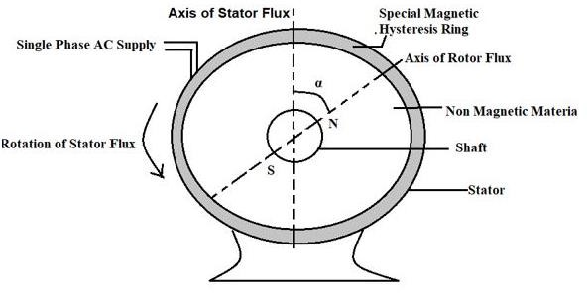

Starting Condition

When an AC supply is provided to the stator, a magnetic field is generated both on main and auxiliary windings of the motor is of the constant rotating magnetic field. Initially, rotors start with eddy current torque and then reach hysteresis torque. Once it reaches synchronization the stator makes the rotor into synchronism where the torque due to eddy current is zero.

Steady State Running Condition

At steady-state running condition (or [synchronous](https://www.elprocus.com/synchronous-motor-working-principle-types/) condition) the stator induces poles on the rotor, where the hysteresis effect produced in the circuit will make the rotor flux lag behind the stator flux at an angle α. Where α is the angle between stator and rotor magnetic fields (BS and BR). Hence the rotor experiences attraction towards the rotating stator, with a torque called hysteresis torque, which does not depend on the speed of the rotor (higher the residual magnetism, higher is the hysteresis torque). The presence of high retentivity allows the motor to operate either with synchronous speed or operates normally.

Advantages

The following are the advantages of the hysteresis motor

* Absence of mechanical vibrations
* It operates noiselessly
* Mainly suitable for accelerating inertia loads Disadvantages

The following are the disadvantages of hysteresis motor

* The output obtained is ¼ times of induction motor
* Small in size
* Torque is less Applications

The following are the applications of hysteresis motor

* Record players
* [Electric clocks](https://www.elprocus.com/digital-alarm-clock-with-8051-microcontroller/)
* Timing devices, etc.

1. Explain the construction and working of stepper motor.

A stepper motor is an electromechanical device that converts electrical energy into mechanical energy. Also, a brushless, synchronous electric motor can rotate the entire rotation in a large number of steps. The position of the motor can be precisely controlled without any reaction mechanism as long as the motor is carefully in the size of the application.

Stepper motors are similar to switched reverse motors. This motor uses the principle of operation for a magnet. The time when the pulse of electricity is supplied will

make the motor shaft a certain distance. The stepper motor stator has eight poles while the rotor has six poles.

To make a complete revolution the rotor would need 24 pulses of electricity to move 24 steps ie, for each pulse of electricity received by the motor, the rotor will move exactly 15 °.

Construction:

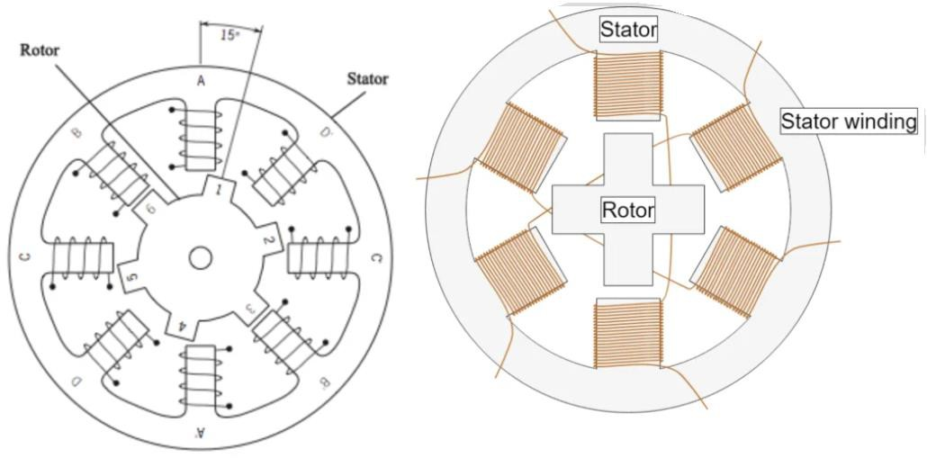

The construction of the stepper motor is similar to that of a DC motor. It consists of a permanent magnet like a rotor which is located in the center and will rotate after its forced action. This rotor is bound by a no stator which is wound by a whole magnetic coil. The stator is arranged close to the rotor. So that the magnetic fields inside the stator can control the speed of the rotor.

This motor can be controlled by giving each stator one power after another. So the stator will become a magnet and act as an electromagnet pole. Which uses the resistive energy on the rotor to move forward. The second magnetizing, as well as demagnetizing of the stator, will slowly shift the rotor and allow it to rotate under greater control.

Working Principle of Stepper Motor:

The working principle of a stepper motor is electro-magnetism. It has a rotor made with a permanent magnet. While the stator is with the electromagnet. Once this is supplied with a power supply a magnetic field is created inside the stator. Now the rotor in the motor continues to move along the rotating magnetic field of the stator. So this is the basic working principle of this motor.

This motor has a soft iron surrounded by electromagnetic. Not based on the type of stator pole as well as the rotor stepper. The stator of this motor is excited once the power is given. The rotor will then rotate to align itself with the stator, otherwise, the minimum distance traveled by the stator. This way the stepper motor is activated in series to rotate.

Driving Techniques:

Due to the intricate design of this motor, the driving techniques of the stepper motor with some special circuits become possible. There are many methods in the market to operate this motor. Four of them are discussed below with an example.

Single Excitation Mode:

The basic method of operating a stepper motor is a single excitation mode. This is an old system that is not used in the current standard. Also need to know about this technique. In this system, the stator will be alternately triggered alternately in each phase or with a special circuit. This will magnetize and demagnetize the stator to move the rotor forward.

Full Step Drive:

In this system, two stators become active in a short period of time. This technic results in higher torque and allows the motor to run with more load.

Half Step Drive:

This system is closely related to full step drive. Because the two stators will be arranged side by side so that it will be activated first then the third will be activated after that. This type of cycle is for replacing the first two stators and then the third

stator will run in the motor. This will result in improved resolution of the stepper motor while reducing the resulting torque from the treadmill.

Micro Stepping:

Micro-stepping systems are used mostly due to inaccuracies. The variable step current will supply the stepper motor drive circuit to the stator coil as a sinusoidal waveform. The accuracy of each step can be increased by this small step current. This system is widely used. This is because it provides more accuracy and at the same time reduces the amount of operating noise.

Types of Stepper motors are :

1. Permanent Magnet Stepper:

This type of motor uses a permanent magnet in the rotor. The rotor acts on the attraction or repulsion between the Permanent Magnet and the stator electromagnet.

This motor is the most common type of motor compared to the different types of stepper motors available in the market. In this motor, a permanent magnet is involved in the construction of the motor. This type of motor is also known as tin-can / can- stack motor. The main advantage of this stepper motor is that its production cost is low. Each revolution has 48-24 steps.

1. Hybrid Synchronous Stepper:

That is why this motor is named. This is because they use a combination of permanent magnets and variable reluctance technic to achieve maximum power in small package sizes.

This is one of the most popular types of motor. This is because the motor gives the best performance compared to a permanent magnet rotor in terms of speed, step resolution, and holding torque. But this motor is expensive compared to Permanent Magnet Stepper Motor.

This motor combines the features of both a permanent magnet and a variable reluctant stepper motor. Such motors are used in places where low stepping angles such as 1.5, 1.8, and 2.5 degrees are required.

1. Variable Reluctance Stepper Motor:

This type of motor has a rotor of plain iron in the variable reluctance motor. And it operates on the principle that the minimum reluctance occurs with the minimum distance, so the rotor points are attracted to the stator magnet poles.

Stepper motors like variable reluctance are the basic type of motor and have been used for many years. As its name suggests, the angular position of the rotor depends primarily on the reluctance of the magnetic circuit. Which can form the teeth of the stator as well as the rotor.

Some of the advantages of the stepper motor are as follows:

* + Easy construction.
  + Hardness.
  + Requires less maintenance.
  + Can work in any situation.
  + Reliability is high.
  + The standalone motor has full torque.
  + Can work in the open-loop control system.
  + Very reliable because there is no contact brush in the motor.
  + The life of a motor depends only on the life of its bearing.
  + Excellent feedback for starting, closing, and vice versa.
  + The rotation angle of the motor is proportional to the input pulse.
  + A wide range of rotational speeds can be experienced as the frequency speed of the input pulses is proportional.

Disadvantages of Stepper Motor:

* + Efficiency is low
  + Accuracy is low.
  + The torque of the motor will decrease rapidly with speed.
  + Small torque towards inertia ratio.
  + Heavy noise.
  + Operating this motor at very high speeds is not easy.
  + A dedicated control circuit is required.
  + Compared to DC motors, it uses more current.
  + Resonance can occur if the motor is not controlled properly. Some of the applications of the stepper motor are as follows:
* Industrial Machine: Stepper motors are used in automotive gauge and machine tooling automatic production devices.
* Security: New surveillance products for the security industry.
* Consumer Electronics: Stepper motors in the camera for automatic digital camera focus and zoom function.
* Medical: Stepper motors are used inside medical scanners, samplers, and are also found inside digital dental photography, fluid pumps, respirators, and blood analysis machinery.

8. Explain the principle of operation and applications of reluctance motor.

The [reluctance motor](http://www.electricalengineeringinfo.com/2016/12/construction-and-working-principle-of-reluctance-motor-applications.html) has basically two main parts called stator and rotor. the stator has a laminated construction, made up of stampings.

The stampings are slotted on its periphery to carry the winding called stator winding. The stator carries only one winding. This is excited by single-phase a.c. supply. The laminated construction keeps iron losses to a minimum. The stampings are made up of material from silicon steel which minimises the [hysteresis loss](http://www.electricalengineeringinfo.com/2016/12/construction-and-working-principle-of-Hysteresis-Motor-applications-disadvantages.html). The stator winding is wound for certain definite number of poles.

The rotor has a particular shape. Due to its shape, the air gap between stator and rotor is not uniform. No d.c supply is given to the rotor. The rotor is free to rotate. The reluctance i.e., the resistance of the magnetic circuit depends

gap between stator and rotor, when the rotor rotates, reluctance between stator and rotor also changes. The stator and rotor are designed in such a manner that the variation of the inductance of the windings is sinusoidal with respect to the rotor position.

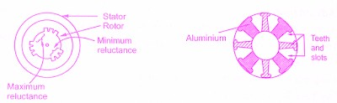

Working Principle of Reluctance Motor:

The stator consists of a Single Winding called main winding. But single winding cannot produce [rotating magnetic field](https://en.wikipedia.org/wiki/Rotating_magnetic_field). So for production of rotating magnetic field, there must be at least two windings separated by the certain phase angle. Hence stator consists of an additional winding called auxiliary winding which consists of a capacitor in series with it.

Thus there exists a phase difference between the currents carried by the two windings and corresponding fluxes. Such two fluxes react to produce the rotating magnetic field. The technique is called split phase technique of production of the rotating magnetic field. The speed of this field is the synchronous speed which is decided by the number of poles for which stator winding is wound.

The rotor carries the short-circuited copper or aluminium bars and it acts as a squirrel-cage rotor of an induction motor. If an iron piece is placed in a magnetic field, it aligns itself in a minimum reluctance position and gets locked magnetically. Similarly, in the [reluctance motor](http://www.electricalengineeringinfo.com/2016/12/construction-and-working-principle-of-reluctance-motor-applications.html), rotor tries to align itself with the axis of rotating magnetic field in a minimum reluctance position. But due to rotor inertia, it is not possible when the rotor is standstill.

So rotor starts rotating near synchronous speed as a squirrel cage induction motor. When the rotor speed is about synchronous, stator magnetic field pulls rotor into synchronism i.e. minimum reluctance position and keeps it magnetically locked. Then rotor continues to rotate with a speed equal to synchronous speed. Such a torque exerted on the rotor is called the reluctance torque. Thus finally the reluctance motor runs as a synchronous motor. The resistance of the rotor must be very shall.

and the combined inertia of the rotor and the load should be small to run the motor as a synchronous motor

Types of Reluctance Motor

Reluctance motors are classified into different types like synchronous and switched.

Synchronous Reluctance Motor

These motors run precisely at synchronous speed and this can be achieved with the help of a three-phase stator winding as well as a rotor to implement salient rotor poles & inner magnetic flux walls. The rotor frequently executes a modified squirrel cage in the region of salient poles, so that it helps from the effect of induction to turn into self-starting. Once the motor activates, it is moved near to synchronous speeds through induction, after that it locks into synchronization through the reluctance torque which is generated from the barriers of rotor flux.

Switched Reluctance Motor

Switched reluctance motor is one kind of [stepper motor](https://www.elprocus.com/stepper-motor-types-advantages-applications/) including some poles. The construction of this motor cost is less as compared with an electric motor due to its simple structure. These motors are mainly used where the rotor is kept inactive for long periods in explosive environments like mining because it works without a mechanical commutator. These motor phase windings are isolated electrically with each other and result in higher fault tolerance as compared with AC induction motor driven by an inverter.

The advantages of reluctance motor include the following.

* It doesn’t require DC supply.
* Stable characteristics
* Maintenance is less
* Less heat
* No magnets
* [Speed control](https://www.elprocus.com/speed-control-of-dc-motor-by-android-application/)

The disadvantages of reluctance motor include the following.

* Efficiency is less
* [Power factor](https://www.elprocus.com/power-factor-calculation/) is poor
* Frequency control
* The capacity of these motors is less to drive the loads
* Less inertia rotor is required.

Applications

The applications of the reluctance motor include the following.

* Signaling Devices
* [Control Devices](https://www.elprocus.com/devices-control-mechanism-used-in-power-electronics/)
* Automatic regulators
* Recording Devices
* Clocks
* Tele printers
* Gramophones
* Analog electric meters
* Electric vehicles
* Power tools like drill lathes, band saws &